**ST. MARY’S RESIDENTIAL CENTRAL SCHOOL,**

**ALAPPUZHA**

**[Affiliated to Central Board of Secondary Education, New Delhi, 930161] *Poonthoppu, Alappuzha-688006***

# *Ph: 2235930, 2232960: Email: stmaryschool@sify.com*



**INFORMATICS PRACTICES PROJECT**

**Certified that this is a bonafide record of the project work done by Sri/Kumari .………..………...................... with Reg.No : …………… in this school during the year 2018-2019.**

**[Seal] Principal**

**Submitted for AISSCE Practical Examination 2018-2019 held on at St. Mary’s Residential Central School, Alappuzha.**

**Internal Examiner External Examiner.**

**CONTENTS**

* ACKNOWLEDGEMENT
* INTRODUCTION
* OBJECTIVE
* USER MANUAL
* DATABASE DESIGN
* MYSQL TABLES
* SOURCE CODE
* SCREENSHOTS
* CONCLUSION
* BIBLIOGRAPHY

ACKNOWLEDGEMENTS

FIRST AND FOREMOST I WOULD LIKE TO THANK GOD, ALMIGHTY FOR SHOWERING HIS BLESSINGS ONTO ME.

I SINCRELY EXPRESS MY DEEP SENSE OF GRATITUDE TO SMT. PREETHY CHAND FOR ENCOURAGING ME TO SUCCESSFULLY COMPLE MY PROJECT.

I WOULD ALSO LIKE TO TAKE THIS OPPORTUNITY TO THANK MY INFORMATICS PRACTICES TEACHER MRS. SHIRLEY PATHROSE WHOLEHEARTEDLY, FOR NOT ONLY HER CONSTANT GUIDANCE BUT ALSO SOURCE OF MOTIIVATION TOWARDS THE COMPLETION OF MY PROJECT.

**INTRODUCTION**

**JAVA**

JAVA IS A POPULAR THIRD-GENERATION PROGRAMMING LANGUAGE, WHICH CAN BE USED TO PERFORM ANY OF THE THOUSANDS OF THINGS THAT COMPUTER SOFTWARE CAN DO. WITH THE FEATURES IT OFFERS, JAVA HAS BECOME THE LANGUAGE OF CHOICE FOR INTERNET AND INTRANET APPLICATION. JAVA PLAYS AN IMPORTANT ROLE FOR THE PROPER FUNCTIONING OF MANY SOFTWARE-BASED DEVICES ATTACHED TO A NETWORK. THE KIND OF FUNCTIONALITY THAT JAVA OFFERS HAS CONTRIBUTED A LOT TOWARDS THE POPULARITY OF JAVA.

JAVA NET BEANS JDC OFFERS A RAD STYLE OF DEVELOPING APPLICATION FOR WINDOWS PROGRAMMERS. WITH NET BEANS JDC, YOU CAN DEVELOP APPLICATIONS BY JUST CREATING FRAMES, DRAGGING AND DROPPING CONTROLS ONTO FRAMES, SETTING PROPERTIES FOR VARIOUS THINGS, ADDING SOME APPLICATION-SPECIFIC CODE TO HANDLE EVENTS AND THAT IS IT.

NET BEANS JDC IS A FREE, OPEN SOURCE, CROSS PLATFORM JDC WITH BUILT-IN SUPPORT FOR JAVA PROGRAMMING LANGUAGE. IN FACT, NET BEANS RUNS ANYWHERE THERE IS A JAVA VIRTUAL MACHINE. NET BEANS OFFERS MANY FEATURES FOR APPLICATION DEVELOPMENT, SUCH AS:

* DRAG AND DROP GUI CREATION
* EXCELLENT EDITING
* WEB SERVICES
* EXCELLENT DEBUGGING
* WIZARDS, CODE GENERATION AND MANAGEMENT TOOLS AND MANY MORE.

**SQL**

A DATABASE SYSTEM IS BASICALLY A COMPUTER BASED RECORD KEEPING SYSTEM. THE COLLECTION OF DATA, USUALLY REFERRED TO AS THE DATABASE, CONTAINS INFORMATION ABOUT ONE PARTICULAR ENTERPRISE. IN A TYPICAL FILE PROCESSING SYSTEM, PERMANENT RECORDS ARE STOREED IN VARIOUS FILES. A NUMBER OF DIFFERENT APPLICATION PROGRAMS ARE RETURN TO EXTRACT RECORDS TO APPROPRIATE FILES. BUT THIS SCHEME HAS A NUMBER OF MAJOR LIMITATIONS AND DISADVANTAGES, SUCH AS DATA REDUDANCY, (DUPLICATION OF DATA) DATA INCONSISTENCY, UNSHARABLE DATA, UNSTANDARIZED DATA, INSECURE DATA, INCORRECT DATA ETC. A DATABASE MANAGAGEMENT SYSTEM IS ANSWER TO ALL THESE PROBLEMS AS IT PROVIDES CENTRALIZED CONTROL OF THE DATA.

Database Connectivity to MYSQL

When you design real life application, you are bound to encounter situations wherein you need to manipulate data stored in a database through an application designed by you.

In order to connect to a database from within an application, you need a framework that helps you send and execute SQL statements from within the applications code .The popular programming interface for accessing relational database is ODBC. But ODBC is Microsoft’s API which cannot to a relational database from within a java application; you can do it by using JDBC API of JAVA.

OBJECTIVES

THIS PROJECT IS BASED ON ONLINE SHOPPING FOR WOMEN.

THIS COMPUTERIZED ONLINE SHOPPING FACILITATES PURCHAESE OF PRODUCTS FROM THE ONLINE SHOPPING SYSTEM.

THESE PRODUCTS CAN BE PURCHASED FROM ANY part of India and it assures free delivery in 7 days.

So, we have tried to create an Online Shopping system through this project.

**USER MANUAL**

* This application is only for the purchase of products for women
* This application is secured with a user id and password.
* After entering the homepage, user can look at various products and purchase it.
* From the home page user can go to various dialogs.
* Clothing Mania(Clothing) Dialog
* Walking Arena(Shoes) Dialog
* Beauty Glitters(Accessories) Dialog
* Beauty Enhancers(Make up) Dialog
* Skin Care Routiners (Skin Products) Dialog
* Magical Hair Centre(Hair Products) Dialog

**DATABASE DESIGN**

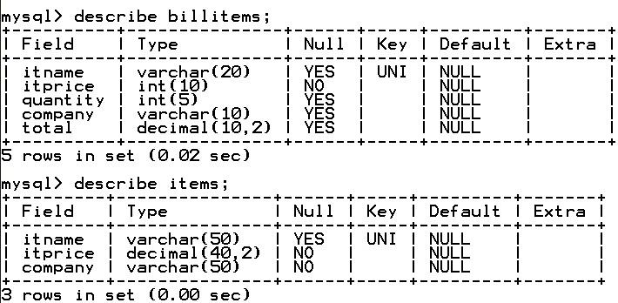

**SOURCE CODE**

import javax.swing.JOptionPane;

import java.sql.*;

import javax.swing.table.DefaultTableModel;

public class BEAUTYSHIELD extends javax.swing.JFrame {

DefaultTableModel tm;

Connection con;

Statement stmt;

ResultSet rs;

String c,nm,z;

float a,t,k;

int b ;

private void jButton2ActionPerformed(java.awt.event.ActionEvent evt) {

logindlg.setVisible(true);// TODO add your handling code here:

}

private void loginbtnActionPerformed(java.awt.event.ActionEvent evt) {

String u=utf.getText();

String p=new String(ppf.getPassword());

if(u.equals("userid@gmail.com"))

{

if(p.equals("marvel"))

{

JOptionPane.showMessageDialog(null,"WELCOME TO THE WORLD OF BEAUTY");

HOME.setVisible(true);

}

else

{

JOptionPane.showMessageDialog(null,"OOPS...ITS SEEM THAT YOU HAE GOT AN ERROR");

ppf.setText("");

ppf.requestFocus();

}

}

else

{

JOptionPane.showMessageDialog(null,"ERROR USERNAME...TRY AGAIN");

utf.setText("");

utf.requestFocus();

}

// TODO add your handling code here:

}

private void jLabel3MousePressed(java.awt.event.MouseEvent evt) {

dressdlg.setVisible(true);// TODO add your handling code here:

}

private void jLabel4MousePressed(java.awt.event.MouseEvent evt) {

acdlg.setVisible(true);// TODO add your handling code here:

}

private void jLabel5MousePressed(java.awt.event.MouseEvent evt) {

mdlg.setVisible(true);// TODO add your handling code here:

}

private void jLabel6MousePressed(java.awt.event.MouseEvent evt) {

hdlg.setVisible(true); // TODO add your handling code here:

}

private void jLabel7MousePressed(java.awt.event.MouseEvent evt) {

bdlg.setVisible(true); // TODO add your handling code here:

}

private void jLabel8MousePressed(java.awt.event.MouseEvent evt) {

sdlg.setVisible(true); // TODO add your handling code here:

}

private void bluetopMousePressed(java.awt.event.MouseEvent evt) {

tm=(DefaultTableModel)carttbl.getModel();

try{

Class.forName("java.sql.Driver");

con=DriverManager.getConnection("jdbc:mysql://localhost/beautyshield","root","sms");

String q="select * from items where itname='bluetop';";

stmt=con.createStatement();

rs=stmt.executeQuery(q);

while(rs.next())

{

nm=rs.getString("itname");

a=rs.getFloat("itprice");

b=Integer.parseInt(JOptionPane.showInputDialog("Enter Quantity"));

t=a*b;

c=rs.getString("company");

Object ob[]={nm,a,c,b,t};

tm.addRow(ob);

}

rs.close();

stmt.close();

con.close();

}

catch(Exception e)

{

JOptionPane.showMessageDialog(null,e.getMessage());

}

try{

Class.forName("com.mysql.jdbc.Driver");

con=DriverManager.getConnection("jdbc:mysql://localhost/beautyshield","root","sms");

stmt=con.createStatement();

String z="insert into billitems values('"+nm+"','"+a+"','"+b+"','"+c+"','"+t+"');";

stmt.executeUpdate(z);

JOptionPane.showMessageDialog(null,"Added successfully");

}

catch(Exception e)

{

JOptionPane.showMessageDialog(null,e.getMessage());

}// TODO add your handling code here:

}

private void jLabel68MousePressed(java.awt.event.MouseEvent evt) {

cartdlg.setVisible(true); // TODO add your handling code here:

}

private void jLabel11MousePressed(java.awt.event.MouseEvent evt) {

tm=(DefaultTableModel)carttbl.getModel();

try{

Class.forName("java.sql.Driver");

con=DriverManager.getConnection("jdbc:mysql://localhost/beautyshield","root","sms");

String q="select * from items where itname='pinktop';";

stmt=con.createStatement();

rs=stmt.executeQuery(q);

while(rs.next())

{

nm=rs.getString("itname");

a=rs.getFloat("itprice");

b=Integer.parseInt(JOptionPane.showInputDialog("Enter Quantity"));

t=a*b;

c=rs.getString("company");

Object ob[]={nm,a,c,b,t};

tm.addRow(ob);

}

rs.close();

stmt.close();

con.close();

}

catch(Exception e)

{

JOptionPane.showMessageDialog(null,e.getMessage());

}

try{

Class.forName("com.mysql.jdbc.Driver");

con=DriverManager.getConnection("jdbc:mysql://localhost/beautyshield","root","sms");

stmt=con.createStatement();

String z="insert into billitems values('"+nm+"','"+a+"','"+b+"','"+c+"','"+t+"');";

stmt.executeUpdate(z);

JOptionPane.showMessageDialog(null,"Added successfully");

}

catch(Exception e)

{

JOptionPane.showMessageDialog(null,e.getMessage());

} // TODO add your handling code here:

}

private void jLabel12MousePressed(java.awt.event.MouseEvent evt) {

tm=(DefaultTableModel)carttbl.getModel();

try{

Class.forName("java.sql.Driver");

con=DriverManager.getConnection("jdbc:mysql://localhost/beautyshield","root","sms");

String q="select * from items where itname='captop';";

stmt=con.createStatement();

rs=stmt.executeQuery(q);

while(rs.next())

{

nm=rs.getString("itname");

a=rs.getFloat("itprice");

b=Integer.parseInt(JOptionPane.showInputDialog("Enter Quantity"));

t=a*b;

c=rs.getString("company");

Object ob[]={nm,a,c,b,t};

tm.addRow(ob);

}

rs.close();

stmt.close();

con.close();

}

catch(Exception e)

{

JOptionPane.showMessageDialog(null,e.getMessage());

}

try{

Class.forName("com.mysql.jdbc.Driver");

con=DriverManager.getConnection("jdbc:mysql://localhost/beautyshield","root","sms");

stmt=con.createStatement();

String z="insert into billitems values('"+nm+"','"+a+"','"+b+"','"+c+"','"+t+"');";

stmt.executeUpdate(z);

JOptionPane.showMessageDialog(null,"Added successfully");

}

catch(Exception e)

{

JOptionPane.showMessageDialog(null,e.getMessage());

} // TODO add your handling code here:

}

private void jLabel14MousePressed(java.awt.event.MouseEvent evt) {

tm=(DefaultTableModel)carttbl.getModel();

try{

Class.forName("java.sql.Driver");

con=DriverManager.getConnection("jdbc:mysql://localhost/beautyshield","root","sms");

String q="select * from items where itname='black jeans';";

stmt=con.createStatement();

rs=stmt.executeQuery(q);

while(rs.next())

{

nm=rs.getString("itname");

a=rs.getFloat("itprice");

b=Integer.parseInt(JOptionPane.showInputDialog("Enter Quantity"));

t=a*b;

c=rs.getString("company");

Object ob[]={nm,a,c,b,t};

tm.addRow(ob);

}

rs.close();

stmt.close();

con.close();

}

catch(Exception e)

{

JOptionPane.showMessageDialog(null,e.getMessage());

}

try{

Class.forName("com.mysql.jdbc.Driver");

con=DriverManager.getConnection("jdbc:mysql://localhost/beautyshield","root","sms");

stmt=con.createStatement();

String z="insert into billitems values('"+nm+"','"+a+"','"+b+"','"+c+"','"+t+"');";

stmt.executeUpdate(z);

JOptionPane.showMessageDialog(null,"Added successfully");

}

catch(Exception e)

{

JOptionPane.showMessageDialog(null,e.getMessage());

} // TODO add your handling code here:

}

private void jLabel15MousePressed(java.awt.event.MouseEvent evt) {

tm=(DefaultTableModel)carttbl.getModel();

try{

Class.forName("java.sql.Driver");

con=DriverManager.getConnection("jdbc:mysql://localhost/beautyshield","root","sms");

String q="select * from items where itname='silk saree';";

stmt=con.createStatement();

rs=stmt.executeQuery(q);

while(rs.next())

{

nm=rs.getString("itname");

a=rs.getFloat("itprice");

b=Integer.parseInt(JOptionPane.showInputDialog("Enter Quantity"));

t=a*b;

c=rs.getString("company");

Object ob[]={nm,a,c,b,t};

tm.addRow(ob);

}

rs.close();

stmt.close();

con.close();

}

catch(Exception e)

{

JOptionPane.showMessageDialog(null,e.getMessage());

}

try{

Class.forName("com.mysql.jdbc.Driver");

con=DriverManager.getConnection("jdbc:mysql://localhost/beautyshield","root","sms");

stmt=con.createStatement();

String z="insert into billitems values('"+nm+"','"+a+"','"+b+"','"+c+"','"+t+"');";

stmt.executeUpdate(z);

JOptionPane.showMessageDialog(null,"Added successfully");

}

catch(Exception e)

{

JOptionPane.showMessageDialog(null,e.getMessage());

} // TODO add your handling code here:

}

private void jLabel16MousePressed(java.awt.event.MouseEvent evt) {

tm=(DefaultTableModel)carttbl.getModel();

try{

Class.forName("java.sql.Driver");

con=DriverManager.getConnection("jdbc:mysql://localhost/beautyshield","root","sms");

String q="select * from items where itname='leatherjacket';";

stmt=con.createStatement();

rs=stmt.executeQuery(q);

while(rs.next())

{

nm=rs.getString("itname");

a=rs.getFloat("itprice");

b=Integer.parseInt(JOptionPane.showInputDialog("Enter Quantity"));

t=a*b;

c=rs.getString("company");

Object ob[]={nm,a,c,b,t};

tm.addRow(ob);

}

rs.close();

stmt.close();

con.close();

}

catch(Exception e)

{

JOptionPane.showMessageDialog(null,e.getMessage());

}

try{

Class.forName("com.mysql.jdbc.Driver");

con=DriverManager.getConnection("jdbc:mysql://localhost/beautyshield","root","sms");

stmt=con.createStatement();

String z="insert into billitems values('"+nm+"','"+a+"','"+b+"','"+c+"','"+t+"');";

stmt.executeUpdate(z);

JOptionPane.showMessageDialog(null,"Added successfully");

}

catch(Exception e)

{

JOptionPane.showMessageDialog(null,e.getMessage());

} // TODO add your handling code here:

}

private void jLabel17MousePressed(java.awt.event.MouseEvent evt) {

tm=(DefaultTableModel)carttbl.getModel();

try{

Class.forName("java.sql.Driver");

con=DriverManager.getConnection("jdbc:mysql://localhost/beautyshield","root","sms");

String q="select * from items where itname='gown';";

stmt=con.createStatement();

rs=stmt.executeQuery(q);

while(rs.next())

{

nm=rs.getString("itname");

a=rs.getFloat("itprice");

b=Integer.parseInt(JOptionPane.showInputDialog("Enter Quantity"));

t=a*b;

c=rs.getString("company");

Object ob[]={nm,a,c,b,t};

tm.addRow(ob);

}

rs.close();

stmt.close();

con.close();

}

catch(Exception e)

{

JOptionPane.showMessageDialog(null,e.getMessage());

}

try{

Class.forName("com.mysql.jdbc.Driver");

con=DriverManager.getConnection("jdbc:mysql://localhost/beautyshield","root","sms");

stmt=con.createStatement();

String z="insert into billitems values('"+nm+"','"+a+"','"+b+"','"+c+"','"+t+"');";

stmt.executeUpdate(z);

JOptionPane.showMessageDialog(null,"Added successfully");

}

catch(Exception e)

{

JOptionPane.showMessageDialog(null,e.getMessage());

} // TODO add your handling code here:

}

private void jLabel18MousePressed(java.awt.event.MouseEvent evt) {

tm=(DefaultTableModel)carttbl.getModel();

try{

Class.forName("java.sql.Driver");

con=DriverManager.getConnection("jdbc:mysql://localhost/beautyshield","root","sms");

String q="select * from items where itname='pallasso';";

stmt=con.createStatement();

rs=stmt.executeQuery(q);

while(rs.next())

{

nm=rs.getString("itname");

a=rs.getFloat("itprice");

b=Integer.parseInt(JOptionPane.showInputDialog("Enter Quantity"));

t=a*b;

c=rs.getString("company");

Object ob[]={nm,a,c,b,t};

tm.addRow(ob);

}

rs.close();

stmt.close();

con.close();

}

catch(Exception e)

{

JOptionPane.showMessageDialog(null,e.getMessage());

}

try{

Class.forName("com.mysql.jdbc.Driver");

con=DriverManager.getConnection("jdbc:mysql://localhost/beautyshield","root","sms");

stmt=con.createStatement();

String z="insert into billitems values('"+nm+"','"+a+"','"+b+"','"+c+"','"+t+"');";

stmt.executeUpdate(z);

JOptionPane.showMessageDialog(null,"Added successfully");

}

catch(Exception e)

{

JOptionPane.showMessageDialog(null,e.getMessage());

} // TODO add your handling code here:

}

private void jLabel19MousePressed(java.awt.event.MouseEvent evt) {

tm=(DefaultTableModel)carttbl.getModel();

try{

Class.forName("java.sql.Driver");

con=DriverManager.getConnection("jdbc:mysql://localhost/beautyshield","root","sms");

String q="select * from items where itname='coldshoulder';";

stmt=con.createStatement();

rs=stmt.executeQuery(q);

while(rs.next())

{

nm=rs.getString("itname");

a=rs.getFloat("itprice");

b=Integer.parseInt(JOptionPane.showInputDialog("Enter Quantity"));

t=a*b;

c=rs.getString("company");

Object ob[]={nm,a,c,b,t};

tm.addRow(ob);

}

rs.close();

stmt.close();

con.close();

}

catch(Exception e)

{

JOptionPane.showMessageDialog(null,e.getMessage());

}

try{

Class.forName("com.mysql.jdbc.Driver");

con=DriverManager.getConnection("jdbc:mysql://localhost/beautyshield","root","sms");

stmt=con.createStatement();

String z="insert into billitems values('"+nm+"','"+a+"','"+b+"','"+c+"','"+t+"');";

stmt.executeUpdate(z);

JOptionPane.showMessageDialog(null,"Added successfully");

}

catch(Exception e)

{

JOptionPane.showMessageDialog(null,e.getMessage());

} // TODO add your handling code here:

}

private void jLabel20MousePressed(java.awt.event.MouseEvent evt) {

tm=(DefaultTableModel)carttbl.getModel();

try{

Class.forName("java.sql.Driver");

con=DriverManager.getConnection("jdbc:mysql://localhost/beautyshield","root","sms");

String q="select * from items where itname='rippedjeans';";

stmt=con.createStatement();

rs=stmt.executeQuery(q);

while(rs.next())

{

nm=rs.getString("itname");

a=rs.getFloat("itprice");

b=Integer.parseInt(JOptionPane.showInputDialog("Enter Quantity"));

t=a*b;

c=rs.getString("company");

Object ob[]={nm,a,c,b,t};

tm.addRow(ob);

}

rs.close();

stmt.close();

con.close();

}

catch(Exception e)

{

JOptionPane.showMessageDialog(null,e.getMessage());

}

try{

Class.forName("com.mysql.jdbc.Driver");

con=DriverManager.getConnection("jdbc:mysql://localhost/beautyshield","root","sms");

stmt=con.createStatement();

String z="insert into billitems values('"+nm+"','"+a+"','"+b+"','"+c+"','"+t+"');";

stmt.executeUpdate(z);

JOptionPane.showMessageDialog(null,"Added successfully");

}

catch(Exception e)

{

JOptionPane.showMessageDialog(null,e.getMessage());

} // TODO add your handling code here:

}

private void jLabel21MousePressed(java.awt.event.MouseEvent evt) {

tm=(DefaultTableModel)carttbl.getModel();

try{

Class.forName("java.sql.Driver");

con=DriverManager.getConnection("jdbc:mysql://localhost/beautyshield","root","sms");

String q="select * from items where itname='scratchjeans';";

stmt=con.createStatement();

rs=stmt.executeQuery(q);

while(rs.next())

{

nm=rs.getString("itname");

a=rs.getFloat("itprice");

b=Integer.parseInt(JOptionPane.showInputDialog("Enter Quantity"));

t=a*b;

c=rs.getString("company");

Object ob[]={nm,a,c,b,t};

tm.addRow(ob);

}

rs.close();

stmt.close();

con.close();

}

catch(Exception e)

{

JOptionPane.showMessageDialog(null,e.getMessage());

}

try{

Class.forName("com.mysql.jdbc.Driver");

con=DriverManager.getConnection("jdbc:mysql://localhost/beautyshield","root","sms");

stmt=con.createStatement();

String z="insert into billitems values('"+nm+"','"+a+"','"+b+"','"+c+"','"+t+"');";

stmt.executeUpdate(z);

JOptionPane.showMessageDialog(null,"Added successfully");

}

catch(Exception e)

{

JOptionPane.showMessageDialog(null,e.getMessage());

} // TODO add your handling code here:

}

private void jLabel22MousePressed(java.awt.event.MouseEvent evt) {

tm=(DefaultTableModel)carttbl.getModel();

try{

Class.forName("java.sql.Driver");

con=DriverManager.getConnection("jdbc:mysql://localhost/beautyshield","root","sms");

String q="select * from items where itname='microjeans';";

stmt=con.createStatement();

rs=stmt.executeQuery(q);

while(rs.next())

{

nm=rs.getString("itname");

a=rs.getFloat("itprice");

b=Integer.parseInt(JOptionPane.showInputDialog("Enter Quantity"));

t=a*b;

c=rs.getString("company");

Object ob[]={nm,a,c,b,t};

tm.addRow(ob);

}

rs.close();

stmt.close();

con.close();

}

catch(Exception e)

{

JOptionPane.showMessageDialog(null,e.getMessage());

}

try{

Class.forName("com.mysql.jdbc.Driver");

con=DriverManager.getConnection("jdbc:mysql://localhost/beautyshield","root","sms");

stmt=con.createStatement();

String z="insert into billitems values('"+nm+"','"+a+"','"+b+"','"+c+"','"+t+"');";

stmt.executeUpdate(z);

JOptionPane.showMessageDialog(null,"Added successfully");

}

catch(Exception e)

{

JOptionPane.showMessageDialog(null,e.getMessage());

} // TODO add your handling code here:

}

private void jLabel24MousePressed(java.awt.event.MouseEvent evt) {

tm=(DefaultTableModel)carttbl.getModel();

try{

Class.forName("java.sql.Driver");

con=DriverManager.getConnection("jdbc:mysql://localhost/beautyshield","root","sms");

String q="select * from items where itname='frock';";

stmt=con.createStatement();

rs=stmt.executeQuery(q);

while(rs.next())

{

nm=rs.getString("itname");

a=rs.getFloat("itprice");

b=Integer.parseInt(JOptionPane.showInputDialog("Enter Quantity"));

t=a*b;

c=rs.getString("company");

Object ob[]={nm,a,c,b,t};

tm.addRow(ob);

}

rs.close();

stmt.close();

con.close();

}

catch(Exception e)

{

JOptionPane.showMessageDialog(null,e.getMessage());

}

try{

Class.forName("com.mysql.jdbc.Driver");

con=DriverManager.getConnection("jdbc:mysql://localhost/beautyshield","root","sms");

stmt=con.createStatement();

String z="insert into billitems values('"+nm+"','"+a+"','"+b+"','"+c+"','"+t+"');";

stmt.executeUpdate(z);

JOptionPane.showMessageDialog(null,"Added successfully");

}

catch(Exception e)

{

JOptionPane.showMessageDialog(null,e.getMessage());

} // TODO add your handling code here:

}

private void jLabel23MousePressed(java.awt.event.MouseEvent evt) {

tm=(DefaultTableModel)carttbl.getModel();

try{

Class.forName("java.sql.Driver");

con=DriverManager.getConnection("jdbc:mysql://localhost/beautyshield","root","sms");

String q="select * from items where itname='tshirt';";

stmt=con.createStatement();

rs=stmt.executeQuery(q);

while(rs.next())

{

nm=rs.getString("itname");

a=rs.getFloat("itprice");

b=Integer.parseInt(JOptionPane.showInputDialog("Enter Quantity"));

t=a*b;

c=rs.getString("company");

Object ob[]={nm,a,c,b,t};

tm.addRow(ob);

}

rs.close();

stmt.close();

con.close();

}

catch(Exception e)

{

JOptionPane.showMessageDialog(null,e.getMessage());

}

try{

Class.forName("com.mysql.jdbc.Driver");

con=DriverManager.getConnection("jdbc:mysql://localhost/beautyshield","root","sms");

stmt=con.createStatement();

String z="insert into billitems values('"+nm+"','"+a+"','"+b+"','"+c+"','"+t+"');";

stmt.executeUpdate(z);

JOptionPane.showMessageDialog(null,"Added successfully");

}

catch(Exception e)

{

JOptionPane.showMessageDialog(null,e.getMessage());

} // TODO add your handling code here:

}

private void jLabel30MousePressed(java.awt.event.MouseEvent evt) {

tm=(DefaultTableModel)carttbl.getModel();

try{

Class.forName("java.sql.Driver");

con=DriverManager.getConnection("jdbc:mysql://localhost/beautyshield","root","sms");

String q="select * from items where itname='pyjama';";

stmt=con.createStatement();

rs=stmt.executeQuery(q);

while(rs.next())

{

nm=rs.getString("itname");

a=rs.getFloat("itprice");

b=Integer.parseInt(JOptionPane.showInputDialog("Enter Quantity"));

t=a*b;

c=rs.getString("company");

Object ob[]={nm,a,c,b,t};

tm.addRow(ob);

}

rs.close();

stmt.close();

con.close();

}

catch(Exception e)

{

JOptionPane.showMessageDialog(null,e.getMessage());

}

try{

Class.forName("com.mysql.jdbc.Driver");

con=DriverManager.getConnection("jdbc:mysql://localhost/beautyshield","root","sms");

stmt=con.createStatement();

String z="insert into billitems values('"+nm+"','"+a+"','"+b+"','"+c+"','"+t+"');";

stmt.executeUpdate(z);

JOptionPane.showMessageDialog(null,"Added successfully");

}

catch(Exception e)

{

JOptionPane.showMessageDialog(null,e.getMessage());

} // TODO add your handling code here:

}

private void jLabel31MousePressed(java.awt.event.MouseEvent evt) {

tm=(DefaultTableModel)carttbl.getModel();

try{

Class.forName("java.sql.Driver");

con=DriverManager.getConnection("jdbc:mysql://localhost/beautyshield","root","sms");

String q="select * from items where itname='jutesilk';";

stmt=con.createStatement();

rs=stmt.executeQuery(q);

while(rs.next())

{

nm=rs.getString("itname");

a=rs.getFloat("itprice");

b=Integer.parseInt(JOptionPane.showInputDialog("Enter Quantity"));

t=a*b;

c=rs.getString("company");

Object ob[]={nm,a,c,b,t};

tm.addRow(ob);

}

rs.close();

stmt.close();

con.close();

}

catch(Exception e)

{

JOptionPane.showMessageDialog(null,e.getMessage());

}

try{

Class.forName("com.mysql.jdbc.Driver");

con=DriverManager.getConnection("jdbc:mysql://localhost/beautyshield","root","sms");

stmt=con.createStatement();

String z="insert into billitems values('"+nm+"','"+a+"','"+b+"','"+c+"','"+t+"');";

stmt.executeUpdate(z);

JOptionPane.showMessageDialog(null,"Added successfully");

}

catch(Exception e)

{

JOptionPane.showMessageDialog(null,e.getMessage());

} // TODO add your handling code here:

}

private void jLabel32MousePressed(java.awt.event.MouseEvent evt) {

tm=(DefaultTableModel)carttbl.getModel();

try{

Class.forName("java.sql.Driver");

con=DriverManager.getConnection("jdbc:mysql://localhost/beautyshield","root","sms");

String q="select * from items where itname='lehanga';";

stmt=con.createStatement();

rs=stmt.executeQuery(q);

while(rs.next())

{

nm=rs.getString("itname");

a=rs.getFloat("itprice");

b=Integer.parseInt(JOptionPane.showInputDialog("Enter Quantity"));

t=a*b;

c=rs.getString("company");

Object ob[]={nm,a,c,b,t};

tm.addRow(ob);

}

rs.close();

stmt.close();

con.close();

}

catch(Exception e)

{

JOptionPane.showMessageDialog(null,e.getMessage());

}

try{

Class.forName("com.mysql.jdbc.Driver");

con=DriverManager.getConnection("jdbc:mysql://localhost/beautyshield","root","sms");

stmt=con.createStatement();

String z="insert into billitems values('"+nm+"','"+a+"','"+b+"','"+c+"','"+t+"');";

stmt.executeUpdate(z);

JOptionPane.showMessageDialog(null,"Added successfully");

}

catch(Exception e)

{

JOptionPane.showMessageDialog(null,e.getMessage());

} // TODO add your handling code here:

}

private void jLabel29MousePressed(java.awt.event.MouseEvent evt) {

tm=(DefaultTableModel)carttbl.getModel();

try{

Class.forName("java.sql.Driver");

con=DriverManager.getConnection("jdbc:mysql://localhost/beautyshield","root","sms");

String q="select * from items where itname='kurti';";

stmt=con.createStatement();

rs=stmt.executeQuery(q);

while(rs.next())

{

nm=rs.getString("itname");

a=rs.getFloat("itprice");

b=Integer.parseInt(JOptionPane.showInputDialog("Enter Quantity"));

t=a*b;

c=rs.getString("company");

Object ob[]={nm,a,c,b,t};

tm.addRow(ob);

}

rs.close();

stmt.close();

con.close();

}

catch(Exception e)

{

JOptionPane.showMessageDialog(null,e.getMessage());

}

try{

Class.forName("com.mysql.jdbc.Driver");

con=DriverManager.getConnection("jdbc:mysql://localhost/beautyshield","root","sms");

stmt=con.createStatement();

String z="insert into billitems values('"+nm+"','"+a+"','"+b+"','"+c+"','"+t+"');";

stmt.executeUpdate(z);

JOptionPane.showMessageDialog(null,"Added successfully");

}

catch(Exception e)

{

JOptionPane.showMessageDialog(null,e.getMessage());

} // TODO add your handling code here:

}

private void jLabel27MousePressed(java.awt.event.MouseEvent evt) {

tm=(DefaultTableModel)carttbl.getModel();

try{

Class.forName("java.sql.Driver");

con=DriverManager.getConnection("jdbc:mysql://localhost/beautyshield","root","sms");

String q="select * from items where itname='bluekurti';";

stmt=con.createStatement();

rs=stmt.executeQuery(q);

while(rs.next())

{

nm=rs.getString("itname");

a=rs.getFloat("itprice");

b=Integer.parseInt(JOptionPane.showInputDialog("Enter Quantity"));

t=a*b;

c=rs.getString("company");

Object ob[]={nm,a,c,b,t};

tm.addRow(ob);

}

rs.close();

stmt.close();

con.close();

}

catch(Exception e)

{

JOptionPane.showMessageDialog(null,e.getMessage());

}

try{

Class.forName("com.mysql.jdbc.Driver");

con=DriverManager.getConnection("jdbc:mysql://localhost/beautyshield","root","sms");

stmt=con.createStatement();

String z="insert into billitems values('"+nm+"','"+a+"','"+b+"','"+c+"','"+t+"');";

stmt.executeUpdate(z);

JOptionPane.showMessageDialog(null,"Added successfully");

}

catch(Exception e)

{

JOptionPane.showMessageDialog(null,e.getMessage());

} // TODO add your handling code here:

}

private void jLabel69MousePressed(java.awt.event.MouseEvent evt) {

tm=(DefaultTableModel)carttbl.getModel();

try{

Class.forName("java.sql.Driver");

con=DriverManager.getConnection("jdbc:mysql://localhost/beautyshield","root","sms");

String q="select * from items where itname='blackjumpsuit';";

stmt=con.createStatement();

rs=stmt.executeQuery(q);

while(rs.next())

{

nm=rs.getString("itname");

a=rs.getFloat("itprice");

b=Integer.parseInt(JOptionPane.showInputDialog("Enter Quantity"));

t=a*b;

c=rs.getString("company");

Object ob[]={nm,a,c,b,t};

tm.addRow(ob);

}

rs.close();

stmt.close();

con.close();

}

catch(Exception e)

{

JOptionPane.showMessageDialog(null,e.getMessage());

}

try{

Class.forName("com.mysql.jdbc.Driver");

con=DriverManager.getConnection("jdbc:mysql://localhost/beautyshield","root","sms");

stmt=con.createStatement();

String z="insert into billitems values('"+nm+"','"+a+"','"+b+"','"+c+"','"+t+"');";

stmt.executeUpdate(z);

JOptionPane.showMessageDialog(null,"Added successfully");

}

catch(Exception e)

{

JOptionPane.showMessageDialog(null,e.getMessage());

}

}

private void jLabel33MousePressed(java.awt.event.MouseEvent evt) {

tm=(DefaultTableModel)carttbl.getModel();

try{

Class.forName("java.sql.Driver");

con=DriverManager.getConnection("jdbc:mysql://localhost/beautyshield","root","sms");

String q="select * from items where itname='redjumpsuit';";

stmt=con.createStatement();

rs=stmt.executeQuery(q);

while(rs.next())

{

nm=rs.getString("itname");

a=rs.getFloat("itprice");

b=Integer.parseInt(JOptionPane.showInputDialog("Enter Quantity"));

t=a*b;

c=rs.getString("company");

Object ob[]={nm,a,c,b,t};

tm.addRow(ob);

}

rs.close();

stmt.close();

con.close();

}

catch(Exception e)

{

JOptionPane.showMessageDialog(null,e.getMessage());

}

try{

Class.forName("com.mysql.jdbc.Driver");

con=DriverManager.getConnection("jdbc:mysql://localhost/beautyshield","root","sms");

stmt=con.createStatement();

String z="insert into billitems values('"+nm+"','"+a+"','"+b+"','"+c+"','"+t+"');";

stmt.executeUpdate(z);

JOptionPane.showMessageDialog(null,"Added successfully");

}

catch(Exception e)

{

JOptionPane.showMessageDialog(null,e.getMessage());

} // TODO add your handling code here:

}

private void jLabel51MousePressed(java.awt.event.MouseEvent evt) {

tm=(DefaultTableModel)carttbl.getModel();

try{

Class.forName("java.sql.Driver");

con=DriverManager.getConnection("jdbc:mysql://localhost/beautyshield","root","sms");

String q="select * from items where itname='crystalearring';";

stmt=con.createStatement();

rs=stmt.executeQuery(q);

while(rs.next())

{

nm=rs.getString("itname");

a=rs.getFloat("itprice");

b=Integer.parseInt(JOptionPane.showInputDialog("Enter Quantity"));

t=a*b;

c=rs.getString("company");

Object ob[]={nm,a,c,b,t};

tm.addRow(ob);

}

rs.close();

stmt.close();

con.close();

}

catch(Exception e)

{

JOptionPane.showMessageDialog(null,e.getMessage());

}

try{

Class.forName("com.mysql.jdbc.Driver");

con=DriverManager.getConnection("jdbc:mysql://localhost/beautyshield","root","sms");

stmt=con.createStatement();

String z="insert into billitems values('"+nm+"','"+a+"','"+b+"','"+c+"','"+t+"');";

stmt.executeUpdate(z);

JOptionPane.showMessageDialog(null,"Added successfully");

}

catch(Exception e)

{

JOptionPane.showMessageDialog(null,e.getMessage());

} // TODO add your handling code here:

}

private void jLabel57MousePressed(java.awt.event.MouseEvent evt) {

tm=(DefaultTableModel)carttbl.getModel();

try{

Class.forName("java.sql.Driver");

con=DriverManager.getConnection("jdbc:mysql://localhost/beautyshield","root","sms");

String q="select * from items where itname='goldchain';";

stmt=con.createStatement();

rs=stmt.executeQuery(q);

while(rs.next())

{

nm=rs.getString("itname");

a=rs.getFloat("itprice");

b=Integer.parseInt(JOptionPane.showInputDialog("Enter Quantity"));

t=a*b;

c=rs.getString("company");

Object ob[]={nm,a,c,b,t};

tm.addRow(ob);

}

rs.close();

stmt.close();

con.close();

}

catch(Exception e)

{

JOptionPane.showMessageDialog(null,e.getMessage());

}

try{

Class.forName("com.mysql.jdbc.Driver");

con=DriverManager.getConnection("jdbc:mysql://localhost/beautyshield","root","sms");

stmt=con.createStatement();

String z="insert into billitems values('"+nm+"','"+a+"','"+b+"','"+c+"','"+t+"');";

stmt.executeUpdate(z);

JOptionPane.showMessageDialog(null,"Added successfully");

}

catch(Exception e)

{

JOptionPane.showMessageDialog(null,e.getMessage());

} // TODO add your handling code here:

}

private void jLabel58MousePressed(java.awt.event.MouseEvent evt) {

tm=(DefaultTableModel)carttbl.getModel();

try{

Class.forName("java.sql.Driver");

con=DriverManager.getConnection("jdbc:mysql://localhost/beautyshield","root","sms");

String q="select * from items where itname='diamondring';";

stmt=con.createStatement();

rs=stmt.executeQuery(q);

while(rs.next())

{

nm=rs.getString("itname");

a=rs.getFloat("itprice");

b=Integer.parseInt(JOptionPane.showInputDialog("Enter Quantity"));

t=a*b;

c=rs.getString("company");

Object ob[]={nm,a,c,b,t};

tm.addRow(ob);

}

rs.close();

stmt.close();

con.close();

}

catch(Exception e)

{

JOptionPane.showMessageDialog(null,e.getMessage());

}

try{

Class.forName("com.mysql.jdbc.Driver");

con=DriverManager.getConnection("jdbc:mysql://localhost/beautyshield","root","sms");

stmt=con.createStatement();

String z="insert into billitems values('"+nm+"','"+a+"','"+b+"','"+c+"','"+t+"');";

stmt.executeUpdate(z);

JOptionPane.showMessageDialog(null,"Added successfully");

}

catch(Exception e)

{

JOptionPane.showMessageDialog(null,e.getMessage());

} // TODO add your handling code here:

}

private void jLabel60MousePressed(java.awt.event.MouseEvent evt) {

tm=(DefaultTableModel)carttbl.getModel();

try{

Class.forName("java.sql.Driver");

con=DriverManager.getConnection("jdbc:mysql://localhost/beautyshield","root","sms");

String q="select * from items where itname='blackwatch';";

stmt=con.createStatement();

rs=stmt.executeQuery(q);

while(rs.next())

{

nm=rs.getString("itname");

a=rs.getFloat("itprice");

b=Integer.parseInt(JOptionPane.showInputDialog("Enter Quantity"));

t=a*b;

c=rs.getString("company");

Object ob[]={nm,a,c,b,t};

tm.addRow(ob);

}

rs.close();

stmt.close();

con.close();

}

catch(Exception e)

{

JOptionPane.showMessageDialog(null,e.getMessage());

}

try{

Class.forName("com.mysql.jdbc.Driver");

con=DriverManager.getConnection("jdbc:mysql://localhost/beautyshield","root","sms");

stmt=con.createStatement();

String z="insert into billitems values('"+nm+"','"+a+"','"+b+"','"+c+"','"+t+"');";

stmt.executeUpdate(z);

JOptionPane.showMessageDialog(null,"Added successfully");

}

catch(Exception e)

{

JOptionPane.showMessageDialog(null,e.getMessage());

}

}

private void jLabel61MousePressed(java.awt.event.MouseEvent evt) {

tm=(DefaultTableModel)carttbl.getModel();

try{

Class.forName("java.sql.Driver");

con=DriverManager.getConnection("jdbc:mysql://localhost/beautyshield","root","sms");

String q="select * from items where itname='bangles';";

stmt=con.createStatement();

rs=stmt.executeQuery(q);

while(rs.next())

{

nm=rs.getString("itname");

a=rs.getFloat("itprice");

b=Integer.parseInt(JOptionPane.showInputDialog("Enter Quantity"));

t=a*b;

c=rs.getString("company");

Object ob[]={nm,a,c,b,t};

tm.addRow(ob);

}

rs.close();

stmt.close();

con.close();

}

catch(Exception e)

{

JOptionPane.showMessageDialog(null,e.getMessage());

}

try{

Class.forName("com.mysql.jdbc.Driver");

con=DriverManager.getConnection("jdbc:mysql://localhost/beautyshield","root","sms");

stmt=con.createStatement();

String z="insert into billitems values('"+nm+"','"+a+"','"+b+"','"+c+"','"+t+"');";

stmt.executeUpdate(z);

JOptionPane.showMessageDialog(null,"Added successfully");

}

catch(Exception e)

{

JOptionPane.showMessageDialog(null,e.getMessage());

} // TODO add your handling code here:

}

private void jLabel10MousePressed(java.awt.event.MouseEvent evt) {

tm=(DefaultTableModel)carttbl.getModel();

try{

Class.forName("java.sql.Driver");

con=DriverManager.getConnection("jdbc:mysql://localhost/beautyshield","root","sms");

String q="select * from items where itname='bracelet';";

stmt=con.createStatement();

rs=stmt.executeQuery(q);

while(rs.next())

{

nm=rs.getString("itname");

a=rs.getFloat("itprice");

b=Integer.parseInt(JOptionPane.showInputDialog("Enter Quantity"));

t=a*b;

c=rs.getString("company");

Object ob[]={nm,a,c,b,t};

tm.addRow(ob);

}

rs.close();

stmt.close();

con.close();

}

catch(Exception e)

{

JOptionPane.showMessageDialog(null,e.getMessage());

}

try{

Class.forName("com.mysql.jdbc.Driver");

con=DriverManager.getConnection("jdbc:mysql://localhost/beautyshield","root","sms");

stmt=con.createStatement();

String z="insert into billitems values('"+nm+"','"+a+"','"+b+"','"+c+"','"+t+"');";

stmt.executeUpdate(z);

JOptionPane.showMessageDialog(null,"Added successfully");

}

catch(Exception e)

{

JOptionPane.showMessageDialog(null,e.getMessage());

} // TODO add your handling code here:

}

private void jLabel44MousePressed(java.awt.event.MouseEvent evt) {

tm=(DefaultTableModel)carttbl.getModel();

try{

Class.forName("java.sql.Driver");

con=DriverManager.getConnection("jdbc:mysql://localhost/beautyshield","root","sms");

String q="select * from items where itname='shampoo';";

stmt=con.createStatement();

rs=stmt.executeQuery(q);

while(rs.next())

{

nm=rs.getString("itname");

a=rs.getFloat("itprice");

b=Integer.parseInt(JOptionPane.showInputDialog("Enter Quantity"));

t=a*b;

c=rs.getString("company");

Object ob[]={nm,a,c,b,t};

tm.addRow(ob);

}

rs.close();

stmt.close();

con.close();

}

catch(Exception e)

{

JOptionPane.showMessageDialog(null,e.getMessage());

}

try{

Class.forName("com.mysql.jdbc.Driver");

con=DriverManager.getConnection("jdbc:mysql://localhost/beautyshield","root","sms");

stmt=con.createStatement();

String z="insert into billitems values('"+nm+"','"+a+"','"+b+"','"+c+"','"+t+"');";

stmt.executeUpdate(z);

JOptionPane.showMessageDialog(null,"Added successfully");

}

catch(Exception e)

{

JOptionPane.showMessageDialog(null,e.getMessage());

} // TODO add your handling code here:

}

private void jLabel48MousePressed(java.awt.event.MouseEvent evt) {

tm=(DefaultTableModel)carttbl.getModel();

try{

Class.forName("java.sql.Driver");

con=DriverManager.getConnection("jdbc:mysql://localhost/beautyshield","root","sms");

String q="select * from items where itname='straightner';";

stmt=con.createStatement();

rs=stmt.executeQuery(q);

while(rs.next())

{

nm=rs.getString("itname");

a=rs.getFloat("itprice");

b=Integer.parseInt(JOptionPane.showInputDialog("Enter Quantity"));

t=a*b;

c=rs.getString("company");

Object ob[]={nm,a,c,b,t};

tm.addRow(ob);

}

rs.close();

stmt.close();

con.close();

}

catch(Exception e)

{

JOptionPane.showMessageDialog(null,e.getMessage());

}

try{

Class.forName("com.mysql.jdbc.Driver");

con=DriverManager.getConnection("jdbc:mysql://localhost/beautyshield","root","sms");

stmt=con.createStatement();

String z="insert into billitems values('"+nm+"','"+a+"','"+b+"','"+c+"','"+t+"');";

stmt.executeUpdate(z);

JOptionPane.showMessageDialog(null,"Added successfully");

}

catch(Exception e)

{

JOptionPane.showMessageDialog(null,e.getMessage());

} // TODO add your handling code here:

}

private void jLabel45MousePressed(java.awt.event.MouseEvent evt) {

tm=(DefaultTableModel)carttbl.getModel();

try{

Class.forName("java.sql.Driver");

con=DriverManager.getConnection("jdbc:mysql://localhost/beautyshield","root","sms");

String q="select * from items where itname='hairdryer';";

stmt=con.createStatement();

rs=stmt.executeQuery(q);

while(rs.next())

{

nm=rs.getString("itname");

a=rs.getFloat("itprice");

b=Integer.parseInt(JOptionPane.showInputDialog("Enter Quantity"));

t=a*b;

c=rs.getString("company");

Object ob[]={nm,a,c,b,t};

tm.addRow(ob);

}

rs.close();

stmt.close();

con.close();

}

catch(Exception e)

{

JOptionPane.showMessageDialog(null,e.getMessage());

}

try{

Class.forName("com.mysql.jdbc.Driver");

con=DriverManager.getConnection("jdbc:mysql://localhost/beautyshield","root","sms");

stmt=con.createStatement();

String z="insert into billitems values('"+nm+"','"+a+"','"+b+"','"+c+"','"+t+"');";

stmt.executeUpdate(z);

JOptionPane.showMessageDialog(null,"Added successfully");

}

catch(Exception e)

{

JOptionPane.showMessageDialog(null,e.getMessage());

} // TODO add your handling code here:

}

private void jLabel49MousePressed(java.awt.event.MouseEvent evt) {

tm=(DefaultTableModel)carttbl.getModel();

try{

Class.forName("java.sql.Driver");

con=DriverManager.getConnection("jdbc:mysql://localhost/beautyshield","root","sms");

String q="select * from items where itname='hairgel';";

stmt=con.createStatement();

rs=stmt.executeQuery(q);

while(rs.next())

{

nm=rs.getString("itname");

a=rs.getFloat("itprice");

b=Integer.parseInt(JOptionPane.showInputDialog("Enter Quantity"));

t=a*b;

c=rs.getString("company");

Object ob[]={nm,a,c,b,t};

tm.addRow(ob);

}

rs.close();

stmt.close();

con.close();

}

catch(Exception e)

{

JOptionPane.showMessageDialog(null,e.getMessage());

}

try{

Class.forName("com.mysql.jdbc.Driver");

con=DriverManager.getConnection("jdbc:mysql://localhost/beautyshield","root","sms");

stmt=con.createStatement();

String z="insert into billitems values('"+nm+"','"+a+"','"+b+"','"+c+"','"+t+"');";

stmt.executeUpdate(z);

JOptionPane.showMessageDialog(null,"Added successfully");

}

catch(Exception e)

{

JOptionPane.showMessageDialog(null,e.getMessage());

} // TODO add your handling code here:

}

private void jLabel46MousePressed(java.awt.event.MouseEvent evt) {

tm=(DefaultTableModel)carttbl.getModel();

try{

Class.forName("java.sql.Driver");

con=DriverManager.getConnection("jdbc:mysql://localhost/beautyshield","root","sms");

String q="select * from items where itname='hairoil';";

stmt=con.createStatement();

rs=stmt.executeQuery(q);

while(rs.next())

{

nm=rs.getString("itname");

a=rs.getFloat("itprice");

b=Integer.parseInt(JOptionPane.showInputDialog("Enter Quantity"));

t=a*b;

c=rs.getString("company");

Object ob[]={nm,a,c,b,t};

tm.addRow(ob);

}

rs.close();

stmt.close();

con.close();

}

catch(Exception e)

{

JOptionPane.showMessageDialog(null,e.getMessage());

}

try{

Class.forName("com.mysql.jdbc.Driver");

con=DriverManager.getConnection("jdbc:mysql://localhost/beautyshield","root","sms");

stmt=con.createStatement();

String z="insert into billitems values('"+nm+"','"+a+"','"+b+"','"+c+"','"+t+"');";

stmt.executeUpdate(z);

JOptionPane.showMessageDialog(null,"Added successfully");

}

catch(Exception e)

{

JOptionPane.showMessageDialog(null,e.getMessage());

} // TODO add your handling code here:

}

private void jLabel50MousePressed(java.awt.event.MouseEvent evt) {

tm=(DefaultTableModel)carttbl.getModel();

try{

Class.forName("java.sql.Driver");

con=DriverManager.getConnection("jdbc:mysql://localhost/beautyshield","root","sms");

String q="select * from items where itname='haircolor';";

stmt=con.createStatement();

rs=stmt.executeQuery(q);

while(rs.next())

{

nm=rs.getString("itname");

a=rs.getFloat("itprice");

b=Integer.parseInt(JOptionPane.showInputDialog("Enter Quantity"));

t=a*b;

c=rs.getString("company");

Object ob[]={nm,a,c,b,t};

tm.addRow(ob);

}

rs.close();

stmt.close();

con.close();

}

catch(Exception e)

{

JOptionPane.showMessageDialog(null,e.getMessage());

}

try{

Class.forName("com.mysql.jdbc.Driver");

con=DriverManager.getConnection("jdbc:mysql://localhost/beautyshield","root","sms");

stmt=con.createStatement();

String z="insert into billitems values('"+nm+"','"+a+"','"+b+"','"+c+"','"+t+"');";

stmt.executeUpdate(z);

JOptionPane.showMessageDialog(null,"Added successfully");

}

catch(Exception e)

{

JOptionPane.showMessageDialog(null,e.getMessage());

} // TODO add your handling code here:

}

private void jLabel47MousePressed(java.awt.event.MouseEvent evt) {

tm=(DefaultTableModel)carttbl.getModel();

try{

Class.forName("java.sql.Driver");

con=DriverManager.getConnection("jdbc:mysql://localhost/beautyshield","root","sms");

String q="select * from items where itname='hairspray';";

stmt=con.createStatement();

rs=stmt.executeQuery(q);

while(rs.next())

{

nm=rs.getString("itname");

a=rs.getFloat("itprice");

b=Integer.parseInt(JOptionPane.showInputDialog("Enter Quantity"));

t=a*b;

c=rs.getString("company");

Object ob[]={nm,a,c,b,t};

tm.addRow(ob);

}

rs.close();

stmt.close();

con.close();

}

catch(Exception e)

{

JOptionPane.showMessageDialog(null,e.getMessage());

}

try{

Class.forName("com.mysql.jdbc.Driver");

con=DriverManager.getConnection("jdbc:mysql://localhost/beautyshield","root","sms");

stmt=con.createStatement();

String z="insert into billitems values('"+nm+"','"+a+"','"+b+"','"+c+"','"+t+"');";

stmt.executeUpdate(z);

JOptionPane.showMessageDialog(null,"Added successfully");

}

catch(Exception e)

{

JOptionPane.showMessageDialog(null,e.getMessage());

} // TODO add your handling code here:

}

private void jLabel34MousePressed(java.awt.event.MouseEvent evt) {

tm=(DefaultTableModel)carttbl.getModel();

try{

Class.forName("java.sql.Driver");

con=DriverManager.getConnection("jdbc:mysql://localhost/beautyshield","root","sms");

String q="select * from items where itname='facecream';";

stmt=con.createStatement();

rs=stmt.executeQuery(q);

while(rs.next())

{

nm=rs.getString("itname");

a=rs.getFloat("itprice");

b=Integer.parseInt(JOptionPane.showInputDialog("Enter Quantity"));

t=a*b;

c=rs.getString("company");

Object ob[]={nm,a,c,b,t};

tm.addRow(ob);

}

rs.close();

stmt.close();

con.close();

}

catch(Exception e)

{

JOptionPane.showMessageDialog(null,e.getMessage());

}

try{

Class.forName("com.mysql.jdbc.Driver");

con=DriverManager.getConnection("jdbc:mysql://localhost/beautyshield","root","sms");

stmt=con.createStatement();

String z="insert into billitems values('"+nm+"','"+a+"','"+b+"','"+c+"','"+t+"');";

stmt.executeUpdate(z);

JOptionPane.showMessageDialog(null,"Added successfully");

}

catch(Exception e)

{

JOptionPane.showMessageDialog(null,e.getMessage());

} // TODO add your handling code here:

}

private void jLabel43MousePressed(java.awt.event.MouseEvent evt) {

tm=(DefaultTableModel)carttbl.getModel();

try{

Class.forName("java.sql.Driver");

con=DriverManager.getConnection("jdbc:mysql://localhost/beautyshield","root","sms");

String q="select * from items where itname='bodylotion';";

stmt=con.createStatement();

rs=stmt.executeQuery(q);

while(rs.next())

{

nm=rs.getString("itname");

a=rs.getFloat("itprice");

b=Integer.parseInt(JOptionPane.showInputDialog("Enter Quantity"));

t=a*b;

c=rs.getString("company");

Object ob[]={nm,a,c,b,t};

tm.addRow(ob);

}

rs.close();

stmt.close();

con.close();

}

catch(Exception e)

{

JOptionPane.showMessageDialog(null,e.getMessage());

}

try{

Class.forName("com.mysql.jdbc.Driver");

con=DriverManager.getConnection("jdbc:mysql://localhost/beautyshield","root","sms");

stmt=con.createStatement();

String z="insert into billitems values('"+nm+"','"+a+"','"+b+"','"+c+"','"+t+"');";

stmt.executeUpdate(z);

JOptionPane.showMessageDialog(null,"Added successfully");

}

catch(Exception e)

{

JOptionPane.showMessageDialog(null,e.getMessage());

} // TODO add your handling code here:

}

private void jLabel55MousePressed(java.awt.event.MouseEvent evt) {

tm=(DefaultTableModel)carttbl.getModel();

try{

Class.forName("java.sql.Driver");

con=DriverManager.getConnection("jdbc:mysql://localhost/beautyshield","root","sms");

String q="select * from items where itname='sunscreen';";

stmt=con.createStatement();

rs=stmt.executeQuery(q);

while(rs.next())

{

nm=rs.getString("itname");

a=rs.getFloat("itprice");

b=Integer.parseInt(JOptionPane.showInputDialog("Enter Quantity"));

t=a*b;

c=rs.getString("company");

Object ob[]={nm,a,c,b,t};

tm.addRow(ob);

}

rs.close();

stmt.close();

con.close();

}

catch(Exception e)

{

JOptionPane.showMessageDialog(null,e.getMessage());

}

try{

Class.forName("com.mysql.jdbc.Driver");

con=DriverManager.getConnection("jdbc:mysql://localhost/beautyshield","root","sms");

stmt=con.createStatement();

String z="insert into billitems values('"+nm+"','"+a+"','"+b+"','"+c+"','"+t+"');";

stmt.executeUpdate(z);

JOptionPane.showMessageDialog(null,"Added successfully");

}

catch(Exception e)

{

JOptionPane.showMessageDialog(null,e.getMessage());

} // TODO add your handling code here:

}

private void jLabel52MousePressed(java.awt.event.MouseEvent evt) {

tm=(DefaultTableModel)carttbl.getModel();

try{

Class.forName("java.sql.Driver");

con=DriverManager.getConnection("jdbc:mysql://localhost/beautyshield","root","sms");

String q="select * from items where itname='facewash';";

stmt=con.createStatement();

rs=stmt.executeQuery(q);

while(rs.next())

{

nm=rs.getString("itname");

a=rs.getFloat("itprice");

b=Integer.parseInt(JOptionPane.showInputDialog("Enter Quantity"));

t=a*b;

c=rs.getString("company");

Object ob[]={nm,a,c,b,t};

tm.addRow(ob);

}

rs.close();

stmt.close();

con.close();

}

catch(Exception e)

{

JOptionPane.showMessageDialog(null,e.getMessage());

}

try{

Class.forName("com.mysql.jdbc.Driver");

con=DriverManager.getConnection("jdbc:mysql://localhost/beautyshield","root","sms");

stmt=con.createStatement();

String z="insert into billitems values('"+nm+"','"+a+"','"+b+"','"+c+"','"+t+"');";

stmt.executeUpdate(z);

JOptionPane.showMessageDialog(null,"Added successfully");

}

catch(Exception e)

{

JOptionPane.showMessageDialog(null,e.getMessage());

} // TODO add your handling code here:

}

private void jLabel56MousePressed(java.awt.event.MouseEvent evt) {

tm=(DefaultTableModel)carttbl.getModel();

try{

Class.forName("java.sql.Driver");

con=DriverManager.getConnection("jdbc:mysql://localhost/beautyshield","root","sms");

String q="select * from items where itname='facebleach';";

stmt=con.createStatement();

rs=stmt.executeQuery(q);

while(rs.next())

{

nm=rs.getString("itname");

a=rs.getFloat("itprice");

b=Integer.parseInt(JOptionPane.showInputDialog("Enter Quantity"));

t=a*b;

c=rs.getString("company");

Object ob[]={nm,a,c,b,t};

tm.addRow(ob);

}

rs.close();

stmt.close();

con.close();

}

catch(Exception e)

{

JOptionPane.showMessageDialog(null,e.getMessage());

}

try{

Class.forName("com.mysql.jdbc.Driver");

con=DriverManager.getConnection("jdbc:mysql://localhost/beautyshield","root","sms");

stmt=con.createStatement();

String z="insert into billitems values('"+nm+"','"+a+"','"+b+"','"+c+"','"+t+"');";

stmt.executeUpdate(z);

JOptionPane.showMessageDialog(null,"Added successfully");

}

catch(Exception e)

{

JOptionPane.showMessageDialog(null,e.getMessage());

} // TODO add your handling code here:

}

private void jLabel53MousePressed(java.awt.event.MouseEvent evt) {

tm=(DefaultTableModel)carttbl.getModel();

try{

Class.forName("java.sql.Driver");

con=DriverManager.getConnection("jdbc:mysql://localhost/beautyshield","root","sms");

String q="select * from items where itname='facescrub';";

stmt=con.createStatement();

rs=stmt.executeQuery(q);

while(rs.next())

{

nm=rs.getString("itname");

a=rs.getFloat("itprice");

b=Integer.parseInt(JOptionPane.showInputDialog("Enter Quantity"));

t=a*b;

c=rs.getString("company");

Object ob[]={nm,a,c,b,t};

tm.addRow(ob);

}

rs.close();

stmt.close();

con.close();

}

catch(Exception e)

{

JOptionPane.showMessageDialog(null,e.getMessage());

}

try{

Class.forName("com.mysql.jdbc.Driver");

con=DriverManager.getConnection("jdbc:mysql://localhost/beautyshield","root","sms");

stmt=con.createStatement();

String z="insert into billitems values('"+nm+"','"+a+"','"+b+"','"+c+"','"+t+"');";

stmt.executeUpdate(z);

JOptionPane.showMessageDialog(null,"Added successfully");

}

catch(Exception e)

{

JOptionPane.showMessageDialog(null,e.getMessage());

} // TODO add your handling code here:

}

private void jLabel54MousePressed(java.awt.event.MouseEvent evt) {

tm=(DefaultTableModel)carttbl.getModel();

try{

Class.forName("java.sql.Driver");

con=DriverManager.getConnection("jdbc:mysql://localhost/beautyshield","root","sms");

String q="select * from items where itname='facepack';";

stmt=con.createStatement();

rs=stmt.executeQuery(q);

while(rs.next())

{

nm=rs.getString("itname");

a=rs.getFloat("itprice");

b=Integer.parseInt(JOptionPane.showInputDialog("Enter Quantity"));

t=a*b;

c=rs.getString("company");

Object ob[]={nm,a,c,b,t};

tm.addRow(ob);

}

rs.close();

stmt.close();

con.close();

}

catch(Exception e)

{

JOptionPane.showMessageDialog(null,e.getMessage());

}

try{

Class.forName("com.mysql.jdbc.Driver");

con=DriverManager.getConnection("jdbc:mysql://localhost/beautyshield","root","sms");

stmt=con.createStatement();

String z="insert into billitems values('"+nm+"','"+a+"','"+b+"','"+c+"','"+t+"');";

stmt.executeUpdate(z);

JOptionPane.showMessageDialog(null,"Added successfully");

}

catch(Exception e)

{

JOptionPane.showMessageDialog(null,e.getMessage());

} // TODO add your handling code here:

}

private void jLabel62MousePressed(java.awt.event.MouseEvent evt) {

tm=(DefaultTableModel)carttbl.getModel();

try{

Class.forName("java.sql.Driver");

con=DriverManager.getConnection("jdbc:mysql://localhost/beautyshield","root","sms");

String q="select * from items where itname='sportsshoe';";

stmt=con.createStatement();

rs=stmt.executeQuery(q);

while(rs.next())

{

nm=rs.getString("itname");

a=rs.getFloat("itprice");

b=Integer.parseInt(JOptionPane.showInputDialog("Enter Quantity"));

t=a*b;

c=rs.getString("company");

Object ob[]={nm,a,c,b,t};

tm.addRow(ob);

}

rs.close();

stmt.close();

con.close();

}

catch(Exception e)

{

JOptionPane.showMessageDialog(null,e.getMessage());

}

try{

Class.forName("com.mysql.jdbc.Driver");

con=DriverManager.getConnection("jdbc:mysql://localhost/beautyshield","root","sms");

stmt=con.createStatement();

String z="insert into billitems values('"+nm+"','"+a+"','"+b+"','"+c+"','"+t+"');";

stmt.executeUpdate(z);

JOptionPane.showMessageDialog(null,"Added successfully");

}

catch(Exception e)

{

JOptionPane.showMessageDialog(null,e.getMessage());

} // TODO add your handling code here:

}

private void jLabel63MousePressed(java.awt.event.MouseEvent evt) {

tm=(DefaultTableModel)carttbl.getModel();

try{

Class.forName("java.sql.Driver");

con=DriverManager.getConnection("jdbc:mysql://localhost/beautyshield","root","sms");

String q="select * from items where itname='highheels';";

stmt=con.createStatement();

rs=stmt.executeQuery(q);

while(rs.next())

{

nm=rs.getString("itname");

a=rs.getFloat("itprice");

b=Integer.parseInt(JOptionPane.showInputDialog("Enter Quantity"));

t=a*b;

c=rs.getString("company");

Object ob[]={nm,a,c,b,t};

tm.addRow(ob);

}

rs.close();

stmt.close();

con.close();

}

catch(Exception e)

{

JOptionPane.showMessageDialog(null,e.getMessage());

}

try{

Class.forName("com.mysql.jdbc.Driver");

con=DriverManager.getConnection("jdbc:mysql://localhost/beautyshield","root","sms");

stmt=con.createStatement();

String z="insert into billitems values('"+nm+"','"+a+"','"+b+"','"+c+"','"+t+"');";

stmt.executeUpdate(z);

JOptionPane.showMessageDialog(null,"Added successfully");

}

catch(Exception e)

{

JOptionPane.showMessageDialog(null,e.getMessage());

} // TODO add your handling code here:

}

private void jLabel64MousePressed(java.awt.event.MouseEvent evt) {

tm=(DefaultTableModel)carttbl.getModel();

try{

Class.forName("java.sql.Driver");

con=DriverManager.getConnection("jdbc:mysql://localhost/beautyshield","root","sms");

String q="select * from items where itname='flipflops';";

stmt=con.createStatement();

rs=stmt.executeQuery(q);

while(rs.next())

{

nm=rs.getString("itname");

a=rs.getFloat("itprice");

b=Integer.parseInt(JOptionPane.showInputDialog("Enter Quantity"));

t=a*b;

c=rs.getString("company");

Object ob[]={nm,a,c,b,t};

tm.addRow(ob);

}

rs.close();

stmt.close();

con.close();

}

catch(Exception e)

{

JOptionPane.showMessageDialog(null,e.getMessage());

}

try{

Class.forName("com.mysql.jdbc.Driver");

con=DriverManager.getConnection("jdbc:mysql://localhost/beautyshield","root","sms");

stmt=con.createStatement();

String z="insert into billitems values('"+nm+"','"+a+"','"+b+"','"+c+"','"+t+"');";

stmt.executeUpdate(z);

JOptionPane.showMessageDialog(null,"Added successfully");

}

catch(Exception e)

{

JOptionPane.showMessageDialog(null,e.getMessage());

} // TODO add your handling code here:

}

private void jLabel65MousePressed(java.awt.event.MouseEvent evt) {

tm=(DefaultTableModel)carttbl.getModel();

try{

Class.forName("java.sql.Driver");

con=DriverManager.getConnection("jdbc:mysql://localhost/beautyshield","root","sms");

String q="select * from items where itname='sandals';";

stmt=con.createStatement();

rs=stmt.executeQuery(q);

while(rs.next())

{

nm=rs.getString("itname");

a=rs.getFloat("itprice");

b=Integer.parseInt(JOptionPane.showInputDialog("Enter Quantity"));

t=a*b;

c=rs.getString("company");

Object ob[]={nm,a,c,b,t};

tm.addRow(ob);

}

rs.close();

stmt.close();

con.close();

}

catch(Exception e)

{

JOptionPane.showMessageDialog(null,e.getMessage());

}

try{

Class.forName("com.mysql.jdbc.Driver");

con=DriverManager.getConnection("jdbc:mysql://localhost/beautyshield","root","sms");

stmt=con.createStatement();

String z="insert into billitems values('"+nm+"','"+a+"','"+b+"','"+c+"','"+t+"');";

stmt.executeUpdate(z);

JOptionPane.showMessageDialog(null,"Added successfully");

}

catch(Exception e)

{

JOptionPane.showMessageDialog(null,e.getMessage());

} // TODO add your handling code here:

}

private void jLabel66MousePressed(java.awt.event.MouseEvent evt) {

tm=(DefaultTableModel)carttbl.getModel();

try{

Class.forName("java.sql.Driver");

con=DriverManager.getConnection("jdbc:mysql://localhost/beautyshield","root","sms");

String q="select * from items where itname='sneakers';";

stmt=con.createStatement();

rs=stmt.executeQuery(q);

while(rs.next())

{

nm=rs.getString("itname");

a=rs.getFloat("itprice");

b=Integer.parseInt(JOptionPane.showInputDialog("Enter Quantity"));

t=a*b;

c=rs.getString("company");

Object ob[]={nm,a,c,b,t};

tm.addRow(ob);

}

rs.close();

stmt.close();

con.close();

}

catch(Exception e)

{

JOptionPane.showMessageDialog(null,e.getMessage());

}

try{

Class.forName("com.mysql.jdbc.Driver");

con=DriverManager.getConnection("jdbc:mysql://localhost/beautyshield","root","sms");

stmt=con.createStatement();

String z="insert into billitems values('"+nm+"','"+a+"','"+b+"','"+c+"','"+t+"');";

stmt.executeUpdate(z);

JOptionPane.showMessageDialog(null,"Added successfully");

}

catch(Exception e)

{

JOptionPane.showMessageDialog(null,e.getMessage());

} // TODO add your handling code here:

}

private void jLabel67MousePressed(java.awt.event.MouseEvent evt) {

tm=(DefaultTableModel)carttbl.getModel();

try{

Class.forName("java.sql.Driver");

con=DriverManager.getConnection("jdbc:mysql://localhost/beautyshield","root","sms");

String q="select * from items where itname='boots';";

stmt=con.createStatement();

rs=stmt.executeQuery(q);

while(rs.next())

{

nm=rs.getString("itname");

a=rs.getFloat("itprice");

b=Integer.parseInt(JOptionPane.showInputDialog("Enter Quantity"));

t=a*b;

c=rs.getString("company");

Object ob[]={nm,a,c,b,t};

tm.addRow(ob);

}

rs.close();

stmt.close();

con.close();

}

catch(Exception e)

{

JOptionPane.showMessageDialog(null,e.getMessage());

}

try{

Class.forName("com.mysql.jdbc.Driver");

con=DriverManager.getConnection("jdbc:mysql://localhost/beautyshield","root","sms");

stmt=con.createStatement();

String z="insert into billitems values('"+nm+"','"+a+"','"+b+"','"+c+"','"+t+"');";

stmt.executeUpdate(z);

JOptionPane.showMessageDialog(null,"Added successfully");

}

catch(Exception e)

{

JOptionPane.showMessageDialog(null,e.getMessage());

} // TODO add your handling code here:

}

private void rembtnActionPerformed(java.awt.event.ActionEvent evt) {

String itnm=(JOptionPane.showInputDialog("Enter itname"));

try

{

Class.forName("java.sql.Driver");

con=DriverManager.getConnection("jdbc:mysql://localhost/beautyshield","root","sms");

String q="delete from billitems where itname='"+itnm+"';";

stmt=con.createStatement();

stmt.executeUpdate(q);

JOptionPane.showMessageDialog(null,"Record successfully removed");

rs.close();

stmt.close();

con.close();

}

catch(Exception e)

{

JOptionPane.showMessageDialog(null,e.getMessage());

}

tm.setRowCount(0);

try

{

Class.forName("java.sql.Driver");

con=DriverManager.getConnection("jdbc:mysql://localhost/beautyshield","root","sms");

String q="select * from billitems;";

Statement stmt=con.createStatement();

ResultSet rs=stmt.executeQuery(q);

while(rs.next())

{

String n=rs.getString("itname");

int k=rs.getInt("itprice");

int j=rs.getInt("quantity");

String h=rs.getString("company");

float f=rs.getFloat("total");

Object ob[]={n,k,j,h,f};

tm.addRow(ob);

}

rs.close();

stmt.close();

con.close();

}

catch(Exception e)

{

JOptionPane.showMessageDialog(null,e.getMessage());

}// TODO add your handling code here:

}

private void jLabel59MousePressed(java.awt.event.MouseEvent evt) {

paydlg.setVisible(true); // TODO add your handling code here:

}

private void jButton3ActionPerformed(java.awt.event.ActionEvent evt) {

DefaultTableModel tm=(DefaultTableModel)carttbl.getModel();

int s=0;

try

{

Class.forName("java.sql.Driver");

Connection con=DriverManager.getConnection("jdbc:mysql://localhost/beautyshield","root","sms");

Statement stmt=con.createStatement();

ResultSet rs=stmt.executeQuery("select sum(total) from billitems;");

while(rs.next())

{

s=rs.getInt("sum(total)");

slbl.setText(""+s);

}

rs.close();

stmt.close();

con.close();

}

catch(Exception e)

{

JOptionPane.showMessageDialog(null,e.getMessage());

}

if(csrb.isSelected())

JOptionPane.showMessageDialog(null,"Cash on Delivery on RS."+s);

if(crrb.isSelected())

JOptionPane.showMessageDialog(null,"Credit Card Transaction on RS."+s);

if(drb.isSelected())

JOptionPane.showMessageDialog(null,"Debit Card Transaction on RS."+s);

thankyoudlg.setVisible(true);// TODO add your handling code here:

}

private void totbtnActionPerformed(java.awt.event.ActionEvent evt) {

DefaultTableModel tm=(DefaultTableModel)carttbl.getModel();

int h=0;

try

{

Class.forName("java.sql.Driver");

Connection con=DriverManager.getConnection("jdbc:mysql://localhost/beautyshield","root","sms");

Statement stmt=con.createStatement();

ResultSet rs=stmt.executeQuery("select sum(total) from billitems;");

while(rs.next())

{

h=rs.getInt("sum(total)");

slbl.setText(""+h);

}

rs.close();

stmt.close();

con.close();

}

catch(Exception e)

{

JOptionPane.showMessageDialog(null,e.getMessage());

}// TODO add your handling code here:

}

private void okbtnActionPerformed(java.awt.event.ActionEvent evt) {

DefaultTableModel tm=(DefaultTableModel)carttbl.getModel();

try

{

Class.forName("java.sql.Driver");

con=DriverManager.getConnection("jdbc:mysql://localhost/beautyshield","root","sms");

String q="delete from billitems;";

stmt=con.createStatement();

stmt.executeUpdate(q);

rs.close();

stmt.close();

con.close();

}

catch(Exception e)

{

JOptionPane.showMessageDialog(null,e.getMessage());

}

tm.removeRow(0);

System.exit(0);// TODO add your handling code here:

}

private void jLabel86MousePressed(java.awt.event.MouseEvent evt) {

DefaultTableModel tm=(DefaultTableModel)carttbl.getModel();

try

{

Class.forName("java.sql.Driver");

con=DriverManager.getConnection("jdbc:mysql://localhost/beautyshield","root","sms");

String q="delete from billitems;";

stmt=con.createStatement();

stmt.executeUpdate(q);

rs.close();

stmt.close();

con.close();

}

catch(Exception e)

{

JOptionPane.showMessageDialog(null,e.getMessage());

}

tm.removeRow(0);

HOME.dispose();

logindlg.dispose();

utf.setText("");

ppf.setText("");// TODO add your handling code here:

}

private void jLabel70MousePressed(java.awt.event.MouseEvent evt) {

tm=(DefaultTableModel)carttbl.getModel();

try{

Class.forName("java.sql.Driver");

con=DriverManager.getConnection("jdbc:mysql://localhost/beautyshield","root","sms");

String q="select * from items where itname='mascara';";

stmt=con.createStatement();

rs=stmt.executeQuery(q);

while(rs.next()) {

nm=rs.getString("itname");

a=rs.getFloat("itprice");

b=Integer.parseInt(JOptionPane.showInputDialog("Enter Quantity"));

t=a*b;

c=rs.getString("company");

Object ob[]={nm,a,c,b,t};

tm.addRow(ob);

}

rs.close();

stmt.close();

con.close();

} catch(Exception e) {

JOptionPane.showMessageDialog(null,e.getMessage());

}

try{

Class.forName("com.mysql.jdbc.Driver");

con=DriverManager.getConnection("jdbc:mysql://localhost/beautyshield","root","sms");

stmt=con.createStatement();

String z="insert into billitems values('"+nm+"','"+a+"','"+b+"','"+c+"','"+t+"');";

stmt.executeUpdate(z);

JOptionPane.showMessageDialog(null,"Added successfully");

} catch(Exception e) {

JOptionPane.showMessageDialog(null,e.getMessage());

} // TODO add your handling code here:

}

private void jLabel42MousePressed(java.awt.event.MouseEvent evt) {

tm=(DefaultTableModel)carttbl.getModel();

try{

Class.forName("java.sql.Driver");

con=DriverManager.getConnection("jdbc:mysql://localhost/beautyshield","root","sms");

String q="select * from items where itname='kajal';";

stmt=con.createStatement();

rs=stmt.executeQuery(q);

while(rs.next()) {

nm=rs.getString("itname");

a=rs.getFloat("itprice");

b=Integer.parseInt(JOptionPane.showInputDialog("Enter Quantity"));

t=a*b;

c=rs.getString("company");

Object ob[]={nm,a,c,b,t};

tm.addRow(ob);

}

rs.close();

stmt.close();

con.close();

} catch(Exception e) {

JOptionPane.showMessageDialog(null,e.getMessage());

}

try{

Class.forName("com.mysql.jdbc.Driver");

con=DriverManager.getConnection("jdbc:mysql://localhost/beautyshield","root","sms");

stmt=con.createStatement();

String z="insert into billitems values('"+nm+"','"+a+"','"+b+"','"+c+"','"+t+"');";

stmt.executeUpdate(z);

JOptionPane.showMessageDialog(null,"Added successfully");

} catch(Exception e) {

JOptionPane.showMessageDialog(null,e.getMessage());

} // TODO add your handling code here:

}

private void jLabel41MousePressed(java.awt.event.MouseEvent evt) {

tm=(DefaultTableModel)carttbl.getModel();

try{

Class.forName("java.sql.Driver");

con=DriverManager.getConnection("jdbc:mysql://localhost/beautyshield","root","sms");

String q="select * from items where itname='redlipliner';";

stmt=con.createStatement();

rs=stmt.executeQuery(q);

while(rs.next()) {

nm=rs.getString("itname");

a=rs.getFloat("itprice");

b=Integer.parseInt(JOptionPane.showInputDialog("Enter Quantity"));

t=a*b;

c=rs.getString("company");

Object ob[]={nm,a,c,b,t};

tm.addRow(ob);

}

rs.close();

stmt.close();

con.close();

} catch(Exception e) {

JOptionPane.showMessageDialog(null,e.getMessage());

}

try{

Class.forName("com.mysql.jdbc.Driver");

con=DriverManager.getConnection("jdbc:mysql://localhost/beautyshield","root","sms");

stmt=con.createStatement();

String z="insert into billitems values('"+nm+"','"+a+"','"+b+"','"+c+"','"+t+"');";

stmt.executeUpdate(z);

JOptionPane.showMessageDialog(null,"Added successfully");

} catch(Exception e) {

JOptionPane.showMessageDialog(null,e.getMessage());

} // TODO add your handling code here:

}

private void jLabel40MousePressed(java.awt.event.MouseEvent evt) {

tm=(DefaultTableModel)carttbl.getModel();

try{

Class.forName("java.sql.Driver");

con=DriverManager.getConnection("jdbc:mysql://localhost/beautyshield","root","sms");

String q="select * from items where itname='blush';";

stmt=con.createStatement();

rs=stmt.executeQuery(q);

while(rs.next()) {

nm=rs.getString("itname");

a=rs.getFloat("itprice");

b=Integer.parseInt(JOptionPane.showInputDialog("Enter Quantity"));

t=a*b;

c=rs.getString("company");

Object ob[]={nm,a,c,b,t};

tm.addRow(ob);

}

rs.close();

stmt.close();

con.close();

} catch(Exception e) {

JOptionPane.showMessageDialog(null,e.getMessage());

}

try{

Class.forName("com.mysql.jdbc.Driver");

con=DriverManager.getConnection("jdbc:mysql://localhost/beautyshield","root","sms");

stmt=con.createStatement();

String z="insert into billitems values('"+nm+"','"+a+"','"+b+"','"+c+"','"+t+"');";

stmt.executeUpdate(z);

JOptionPane.showMessageDialog(null,"Added successfully");

} catch(Exception e) {

JOptionPane.showMessageDialog(null,e.getMessage());

} // TODO add your handling code here:

}

private void jLabel39MousePressed(java.awt.event.MouseEvent evt) {

tm=(DefaultTableModel)carttbl.getModel();

try{

Class.forName("java.sql.Driver");

con=DriverManager.getConnection("jdbc:mysql://localhost/beautyshield","root","sms");

String q="select * from items where itname='compact';";

stmt=con.createStatement();

rs=stmt.executeQuery(q);

while(rs.next()) {

nm=rs.getString("itname");

a=rs.getFloat("itprice");

b=Integer.parseInt(JOptionPane.showInputDialog("Enter Quantity"));

t=a*b;

c=rs.getString("company");

Object ob[]={nm,a,c,b,t};

tm.addRow(ob);

}

rs.close();

stmt.close();

con.close();

} catch(Exception e) {

JOptionPane.showMessageDialog(null,e.getMessage());

}

try{

Class.forName("com.mysql.jdbc.Driver");

con=DriverManager.getConnection("jdbc:mysql://localhost/beautyshield","root","sms");

stmt=con.createStatement();

String z="insert into billitems values('"+nm+"','"+a+"','"+b+"','"+c+"','"+t+"');";

stmt.executeUpdate(z);

JOptionPane.showMessageDialog(null,"Added successfully");

} catch(Exception e) {

JOptionPane.showMessageDialog(null,e.getMessage());

} // TODO add your handling code here:

}

private void jLabel38MousePressed(java.awt.event.MouseEvent evt) {

tm=(DefaultTableModel)carttbl.getModel();

try{

Class.forName("java.sql.Driver");

con=DriverManager.getConnection("jdbc:mysql://localhost/beautyshield","root","sms");

String q="select * from items where itname='eyeshadow';";

stmt=con.createStatement();

rs=stmt.executeQuery(q);

while(rs.next()) {

nm=rs.getString("itname");

a=rs.getFloat("itprice");

b=Integer.parseInt(JOptionPane.showInputDialog("Enter Quantity"));

t=a*b;

c=rs.getString("company");

Object ob[]={nm,a,c,b,t};

tm.addRow(ob);

}

rs.close();

stmt.close();

con.close();

} catch(Exception e) {

JOptionPane.showMessageDialog(null,e.getMessage());

}

try{

Class.forName("com.mysql.jdbc.Driver");

con=DriverManager.getConnection("jdbc:mysql://localhost/beautyshield","root","sms");

stmt=con.createStatement();

String z="insert into billitems values('"+nm+"','"+a+"','"+b+"','"+c+"','"+t+"');";

stmt.executeUpdate(z);

JOptionPane.showMessageDialog(null,"Added successfully");

} catch(Exception e) {

JOptionPane.showMessageDialog(null,e.getMessage());

} // TODO add your handling code here:

}

private void jLabel37MousePressed(java.awt.event.MouseEvent evt) {

tm=(DefaultTableModel)carttbl.getModel();

try{

Class.forName("java.sql.Driver");

con=DriverManager.getConnection("jdbc:mysql://localhost/beautyshield","root","sms");

String q="select * from items where itname='pinklipgloss';";

stmt=con.createStatement();

rs=stmt.executeQuery(q);

while(rs.next()) {

nm=rs.getString("itname");

a=rs.getFloat("itprice");

b=Integer.parseInt(JOptionPane.showInputDialog("Enter Quantity"));

t=a*b;

c=rs.getString("company");

Object ob[]={nm,a,c,b,t};

tm.addRow(ob);

}

rs.close();

stmt.close();

con.close();

} catch(Exception e) {

JOptionPane.showMessageDialog(null,e.getMessage());

}

try{

Class.forName("com.mysql.jdbc.Driver");

con=DriverManager.getConnection("jdbc:mysql://localhost/beautyshield","root","sms");

stmt=con.createStatement();

String z="insert into billitems values('"+nm+"','"+a+"','"+b+"','"+c+"','"+t+"');";

stmt.executeUpdate(z);

JOptionPane.showMessageDialog(null,"Added successfully");

} catch(Exception e) {

JOptionPane.showMessageDialog(null,e.getMessage());

} // TODO add your handling code here:

}

private void jLabel36MousePressed(java.awt.event.MouseEvent evt) {

tm=(DefaultTableModel)carttbl.getModel();

try{

Class.forName("java.sql.Driver");

con=DriverManager.getConnection("jdbc:mysql://localhost/beautyshield","root","sms");

String q="select * from items where itname='blackeyeliner';";

stmt=con.createStatement();

rs=stmt.executeQuery(q);

while(rs.next()) {

nm=rs.getString("itname");

a=rs.getFloat("itprice");

b=Integer.parseInt(JOptionPane.showInputDialog("Enter Quantity"));

t=a*b;

c=rs.getString("company");

Object ob[]={nm,a,c,b,t};

tm.addRow(ob);

}

rs.close();

stmt.close();

con.close();

} catch(Exception e) {

JOptionPane.showMessageDialog(null,e.getMessage());

}

try{

Class.forName("com.mysql.jdbc.Driver");

con=DriverManager.getConnection("jdbc:mysql://localhost/beautyshield","root","sms");

stmt=con.createStatement();

String z="insert into billitems values('"+nm+"','"+a+"','"+b+"','"+c+"','"+t+"');";

stmt.executeUpdate(z);

JOptionPane.showMessageDialog(null,"Added successfully");

} catch(Exception e) {

JOptionPane.showMessageDialog(null,e.getMessage());

} // TODO add your handling code here:

}

private void jLabel35MousePressed(java.awt.event.MouseEvent evt) {

tm=(DefaultTableModel)carttbl.getModel();

try{

Class.forName("java.sql.Driver");

con=DriverManager.getConnection("jdbc:mysql://localhost/beautyshield","root","sms");

String q="select * from items where itname='redlipstick';";

stmt=con.createStatement();

rs=stmt.executeQuery(q);

while(rs.next()) {

nm=rs.getString("itname");

a=rs.getFloat("itprice");

b=Integer.parseInt(JOptionPane.showInputDialog("Enter Quantity"));

t=a*b;

c=rs.getString("company");

Object ob[]={nm,a,c,b,t};

tm.addRow(ob);

}

rs.close();

stmt.close();

con.close();

} catch(Exception e) {

JOptionPane.showMessageDialog(null,e.getMessage());

}

try{

Class.forName("com.mysql.jdbc.Driver");

con=DriverManager.getConnection("jdbc:mysql://localhost/beautyshield","root","sms");

stmt=con.createStatement();

String z="insert into billitems values('"+nm+"','"+a+"','"+b+"','"+c+"','"+t+"');";

stmt.executeUpdate(z);

JOptionPane.showMessageDialog(null,"Added successfully");

} catch(Exception e) {

JOptionPane.showMessageDialog(null,e.getMessage());

} // TODO add your handling code here:

}

private void jLabel9MousePressed(java.awt.event.MouseEvent evt) {

tm=(DefaultTableModel)carttbl.getModel();

try{

Class.forName("java.sql.Driver");

con=DriverManager.getConnection("jdbc:mysql://localhost/beautyshield","root","sms");

String q="select * from items where itname='foundation';";

stmt=con.createStatement();

rs=stmt.executeQuery(q);

while(rs.next()) {

nm=rs.getString("itname");

a=rs.getFloat("itprice");

b=Integer.parseInt(JOptionPane.showInputDialog("Enter Quantity"));

t=a*b;

c=rs.getString("company");

Object ob[]={nm,a,c,b,t};

tm.addRow(ob);

}

rs.close();

stmt.close();

con.close();

} catch(Exception e) {

JOptionPane.showMessageDialog(null,e.getMessage());

}

try{

Class.forName("com.mysql.jdbc.Driver");

con=DriverManager.getConnection("jdbc:mysql://localhost/beautyshield","root","sms");

stmt=con.createStatement();

String z="insert into billitems values('"+nm+"','"+a+"','"+b+"','"+c+"','"+t+"');";

stmt.executeUpdate(z);

JOptionPane.showMessageDialog(null,"Added successfully");

} catch(Exception e) {

JOptionPane.showMessageDialog(null,e.getMessage());

} // TODO add your handling code here:

}

private void jLabel139MousePressed(java.awt.event.MouseEvent evt) {

dressdlg.dispose();// TODO add your handling code here:

}

private void jLabel140MousePressed(java.awt.event.MouseEvent evt) {

DefaultTableModel tm=(DefaultTableModel)carttbl.getModel();

try

{

Class.forName("java.sql.Driver");

con=DriverManager.getConnection("jdbc:mysql://localhost/beautyshield","root","sms");

String q="delete from billitems;";

stmt=con.createStatement();

stmt.executeUpdate(q);

rs.close();

stmt.close();

con.close();

}

catch(Exception e)

{

JOptionPane.showMessageDialog(null,e.getMessage());

}

tm.removeRow(0);

dressdlg.dispose();

HOME.dispose();

logindlg.dispose();

utf.setText("");

ppf.setText("");// TODO add your handling code here:

}

private void jLabel141MousePressed(java.awt.event.MouseEvent evt) {

dressdlg.dispose();

cartdlg.setVisible(true); // TODO add your handling code here:

}

private void jLabel112MousePressed(java.awt.event.MouseEvent evt) {

mdlg.dispose(); // TODO add your handling code here:

}

private void jLabel110MousePressed(java.awt.event.MouseEvent evt) {

DefaultTableModel tm=(DefaultTableModel)carttbl.getModel();

try

{

Class.forName("java.sql.Driver");

con=DriverManager.getConnection("jdbc:mysql://localhost/beautyshield","root","sms");

String q="delete from billitems;";

stmt=con.createStatement();

stmt.executeUpdate(q);

rs.close();

stmt.close();

con.close();

}

catch(Exception e)

{

JOptionPane.showMessageDialog(null,e.getMessage());

}

tm.removeRow(0);

mdlg.dispose();

HOME.dispose();

logindlg.dispose();

utf.setText("");

ppf.setText("");// TODO add your handling code here:

}

private void jLabel111MousePressed(java.awt.event.MouseEvent evt) {

mdlg.dispose();

cartdlg.setVisible(true);// TODO add your handling code here:

}

private void jLabel138MousePressed(java.awt.event.MouseEvent evt) {

acdlg.dispose(); // TODO add your handling code here:

}

private void jLabel147MousePressed(java.awt.event.MouseEvent evt) {

hdlg.dispose(); // TODO add your handling code here:

}

private void jLabel156MousePressed(java.awt.event.MouseEvent evt) {

bdlg.dispose(); // TODO add your handling code here:

}

private void jLabel152MousePressed(java.awt.event.MouseEvent evt) {

sdlg.dispose(); // TODO add your handling code here:

}

private void jLabel159MousePressed(java.awt.event.MouseEvent evt) {

cartdlg.dispose(); // TODO add your handling code here:

}

private void jLabel104MousePressed(java.awt.event.MouseEvent evt) {

DefaultTableModel tm=(DefaultTableModel)carttbl.getModel();

try

{

Class.forName("java.sql.Driver");

con=DriverManager.getConnection("jdbc:mysql://localhost/beautyshield","root","sms");

String q="delete from billitems;";

stmt=con.createStatement();

stmt.executeUpdate(q);

rs.close();

stmt.close();

con.close();

}

catch(Exception e)

{

JOptionPane.showMessageDialog(null,e.getMessage());

}

tm.removeRow(0);

acdlg.dispose();

HOME.dispose();

logindlg.dispose();

utf.setText("");

ppf.setText("");// TODO add your handling code here:

}

private void jLabel105MousePressed(java.awt.event.MouseEvent evt) {

acdlg.dispose();

cartdlg.setVisible(true); // TODO add your handling code here:

}

private void jLabel148MousePressed(java.awt.event.MouseEvent evt) {

DefaultTableModel tm=(DefaultTableModel)carttbl.getModel();

try

{

Class.forName("java.sql.Driver");

con=DriverManager.getConnection("jdbc:mysql://localhost/beautyshield","root","sms");

String q="delete from billitems;";

stmt=con.createStatement();

stmt.executeUpdate(q);

rs.close();

stmt.close();

con.close();

}

catch(Exception e)

{

JOptionPane.showMessageDialog(null,e.getMessage());

}

tm.removeRow(0);

hdlg.dispose();

HOME.dispose();

logindlg.dispose();

utf.setText("");

ppf.setText("");// TODO add your handling code here:

}

private void jLabel155MousePressed(java.awt.event.MouseEvent evt) {

hdlg.dispose();

cartdlg.setVisible(true); // TODO add your handling code here:

}

private void jLabel157MousePressed(java.awt.event.MouseEvent evt) {

DefaultTableModel tm=(DefaultTableModel)carttbl.getModel();

try

{

Class.forName("java.sql.Driver");

con=DriverManager.getConnection("jdbc:mysql://localhost/beautyshield","root","sms");

String q="delete from billitems;";

stmt=con.createStatement();

stmt.executeUpdate(q);

rs.close();

stmt.close();

con.close();

}

catch(Exception e)

{

JOptionPane.showMessageDialog(null,e.getMessage());

}

tm.removeRow(0);

bdlg.dispose();

HOME.dispose();

logindlg.dispose();

utf.setText("");

ppf.setText("");// TODO add your handling code here:

}

private void jLabel158MousePressed(java.awt.event.MouseEvent evt) {

bdlg.dispose();

cartdlg.setVisible(true); // TODO add your handling code here:

}

private void jLabel153MousePressed(java.awt.event.MouseEvent evt) {

sdlg.dispose();

cartdlg.setVisible(true); // TODO add your handling code here:

}

private void jLabel151MousePressed(java.awt.event.MouseEvent evt) {

DefaultTableModel tm=(DefaultTableModel)carttbl.getModel();

try

{

Class.forName("java.sql.Driver");

con=DriverManager.getConnection("jdbc:mysql://localhost/beautyshield","root","sms");

String q="delete from billitems;";

stmt=con.createStatement();

stmt.executeUpdate(q);

rs.close();

stmt.close();

con.close();

}

catch(Exception e)

{

JOptionPane.showMessageDialog(null,e.getMessage());

}

tm.removeRow(0);

sdlg.dispose();

HOME.dispose();

logindlg.dispose();

utf.setText("");

ppf.setText("");// TODO add your handling code here:

}

private void jLabel160MousePressed(java.awt.event.MouseEvent evt) {

DefaultTableModel tm=(DefaultTableModel)carttbl.getModel();

try

{

Class.forName("java.sql.Driver");

con=DriverManager.getConnection("jdbc:mysql://localhost/beautyshield","root","sms");

String q="delete from billitems;";

stmt=con.createStatement();

stmt.executeUpdate(q);

rs.close();

stmt.close();

con.close();

}

catch(Exception e)

{

JOptionPane.showMessageDialog(null,e.getMessage());

}

tm.removeRow(0);

cartdlg.dispose();

HOME.dispose();

logindlg.dispose();

utf.setText("");

ppf.setText("");// TODO add your handling code here:

}

private void jButton1ActionPerformed(java.awt.event.ActionEvent evt) {

dressdlg2.setVisible(true); // TODO add your handling code here:

}

private void jButton4ActionPerformed(java.awt.event.ActionEvent evt) {

dressdlg2.dispose(); // TODO add your handling code here:

}

private void jLabel264MousePressed(java.awt.event.MouseEvent evt) {

tm=(DefaultTableModel)carttbl.getModel();

try{

Class.forName("java.sql.Driver");

con=DriverManager.getConnection("jdbc:mysql://localhost/beautyshield","root","sms");

String q="select * from items where itname='croptop';";

stmt=con.createStatement();

rs=stmt.executeQuery(q);

while(rs.next())

{

nm=rs.getString("itname");

a=rs.getFloat("itprice");

b=Integer.parseInt(JOptionPane.showInputDialog("Enter Quantity"));

t=a*b;

c=rs.getString("company");

Object ob[]={nm,a,c,b,t};

tm.addRow(ob);

}

rs.close();

stmt.close();

con.close();

}

catch(Exception e)

{

JOptionPane.showMessageDialog(null,e.getMessage());

}

try{

Class.forName("com.mysql.jdbc.Driver");

con=DriverManager.getConnection("jdbc:mysql://localhost/beautyshield","root","sms");

stmt=con.createStatement();

String z="insert into billitems values('"+nm+"','"+a+"','"+b+"','"+c+"','"+t+"');";

stmt.executeUpdate(z);

JOptionPane.showMessageDialog(null,"Added successfully");

}

catch(Exception e)

{

JOptionPane.showMessageDialog(null,e.getMessage());

} // TODO add your handling code here:

}

private void jLabel265MousePressed(java.awt.event.MouseEvent evt) {

tm=(DefaultTableModel)carttbl.getModel();

try{

Class.forName("java.sql.Driver");

con=DriverManager.getConnection("jdbc:mysql://localhost/beautyshield","root","sms");

String q="select * from items where itname='pinkkurti';";

stmt=con.createStatement();

rs=stmt.executeQuery(q);

while(rs.next())

{

nm=rs.getString("itname");

a=rs.getFloat("itprice");

b=Integer.parseInt(JOptionPane.showInputDialog("Enter Quantity"));

t=a*b;

c=rs.getString("company");

Object ob[]={nm,a,c,b,t};

tm.addRow(ob);

}

rs.close();

stmt.close();

con.close();

}

catch(Exception e)

{

JOptionPane.showMessageDialog(null,e.getMessage());

}

try{

Class.forName("com.mysql.jdbc.Driver");

con=DriverManager.getConnection("jdbc:mysql://localhost/beautyshield","root","sms");

stmt=con.createStatement();

String z="insert into billitems values('"+nm+"','"+a+"','"+b+"','"+c+"','"+t+"');";

stmt.executeUpdate(z);

JOptionPane.showMessageDialog(null,"Added successfully");

}

catch(Exception e)

{

JOptionPane.showMessageDialog(null,e.getMessage());

} // TODO add your handling code here:

}

private void jLabel266MousePressed(java.awt.event.MouseEvent evt) {

tm=(DefaultTableModel)carttbl.getModel();

try{

Class.forName("java.sql.Driver");

con=DriverManager.getConnection("jdbc:mysql://localhost/beautyshield","root","sms");

String q="select * from items where itname='jacket';";

stmt=con.createStatement();

rs=stmt.executeQuery(q);

while(rs.next())

{

nm=rs.getString("itname");

a=rs.getFloat("itprice");

b=Integer.parseInt(JOptionPane.showInputDialog("Enter Quantity"));

t=a*b;

c=rs.getString("company");

Object ob[]={nm,a,c,b,t};

tm.addRow(ob);

}

rs.close();

stmt.close();

con.close();

}

catch(Exception e)

{

JOptionPane.showMessageDialog(null,e.getMessage());

}

try{

Class.forName("com.mysql.jdbc.Driver");

con=DriverManager.getConnection("jdbc:mysql://localhost/beautyshield","root","sms");

stmt=con.createStatement();

String z="insert into billitems values('"+nm+"','"+a+"','"+b+"','"+c+"','"+t+"');";

stmt.executeUpdate(z);

JOptionPane.showMessageDialog(null,"Added successfully");

}

catch(Exception e)

{

JOptionPane.showMessageDialog(null,e.getMessage());

} // TODO add your handling code here:

}

private void jButton5ActionPerformed(java.awt.event.ActionEvent evt) {

dressdlg3.setVisible(true); // TODO add your handling code here:

}

private void jLabel185MousePressed(java.awt.event.MouseEvent evt) {

dressdlg2.dispose();

dressdlg.dispose(); // TODO add your handling code here:

}

private void jLabel28MousePressed(java.awt.event.MouseEvent evt) {

dressdlg3.dispose();

dressdlg2.dispose();

dressdlg.dispose();// TODO add your handling code here:

}

private void jLabel186MousePressed(java.awt.event.MouseEvent evt) {

utf.setText("");

ppf.setText("");

dressdlg2.dispose();

dressdlg.dispose();

HOME.dispose();

logindlg.dispose(); // TODO add your handling code here:

}

private void jLabel254MousePressed(java.awt.event.MouseEvent evt) {

utf.setText("");

ppf.setText("");

dressdlg3.dispose();

dressdlg2.dispose();

dressdlg.dispose();

HOME.dispose();

logindlg.dispose(); // TODO add your handling code here:

}

private void jLabel187MousePressed(java.awt.event.MouseEvent evt) {

dressdlg2.dispose();

dressdlg.dispose();

cartdlg.setVisible(true); // TODO add your handling code here:

}

private void jLabel256MousePressed(java.awt.event.MouseEvent evt) {

dressdlg3.dispose();

dressdlg2.dispose();

dressdlg.dispose();

cartdlg.setVisible(true); // TODO add your handling code here:

}

private void jButton6ActionPerformed(java.awt.event.ActionEvent evt) {

dressdlg3.dispose();// TODO add your handling code here:

}

**SCREENSHOTS**

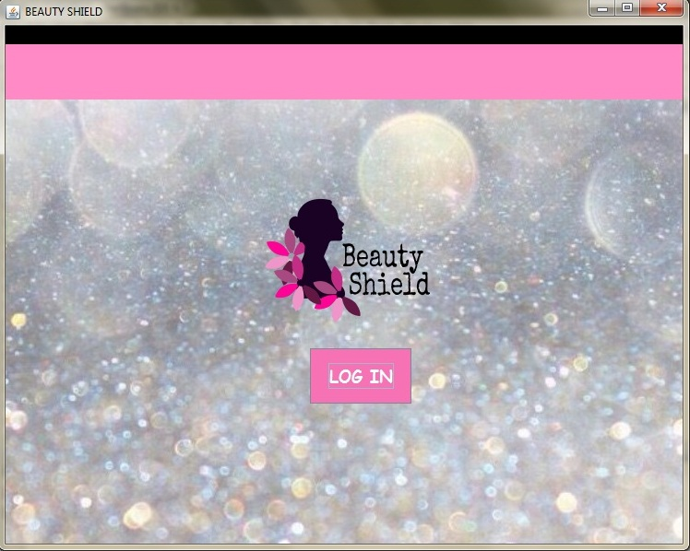

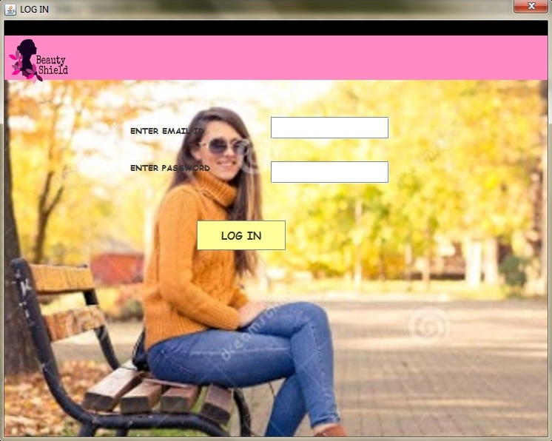

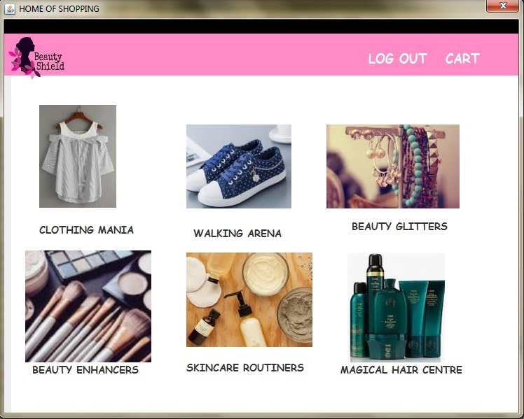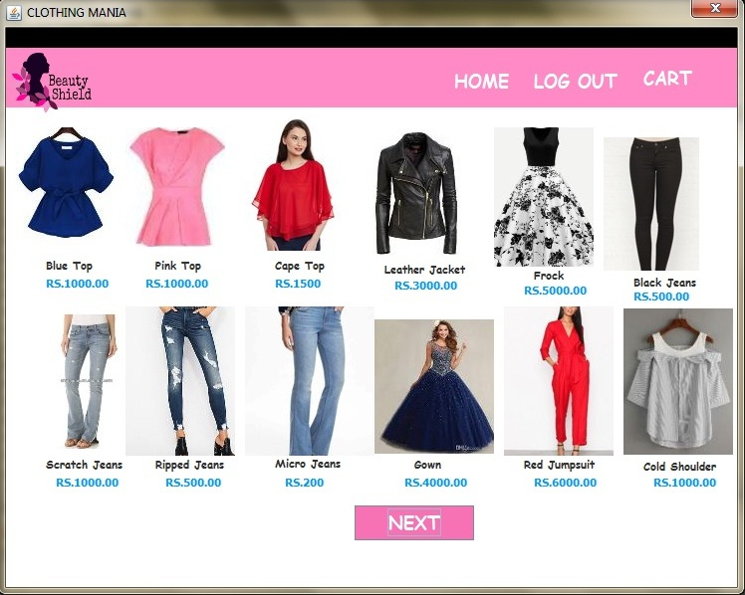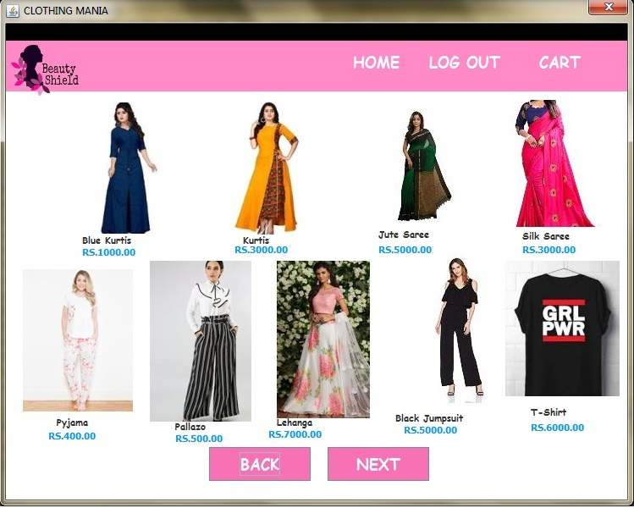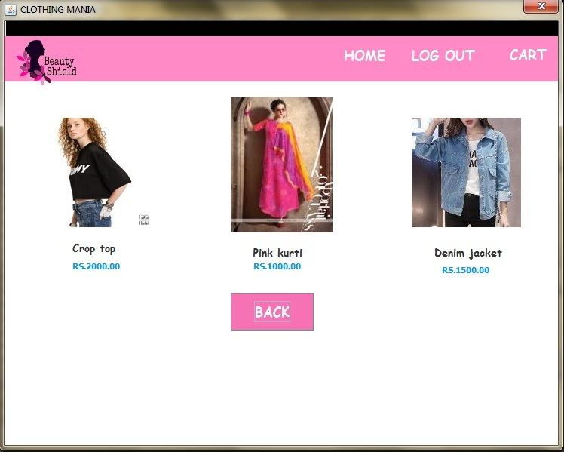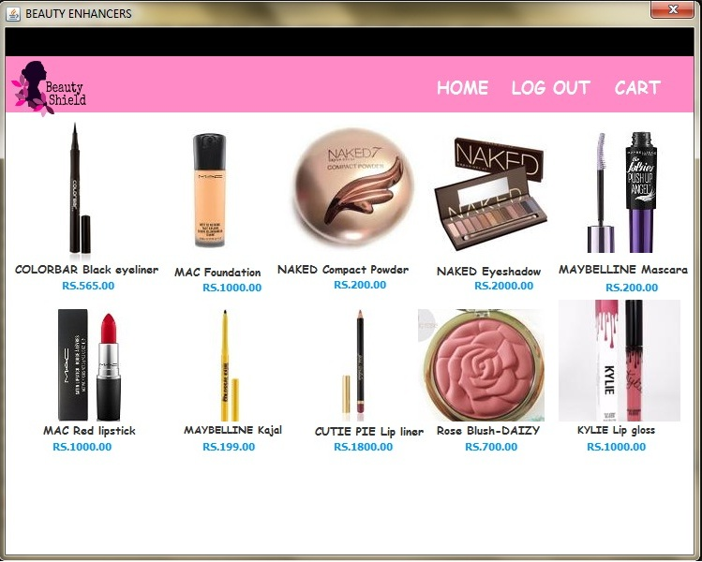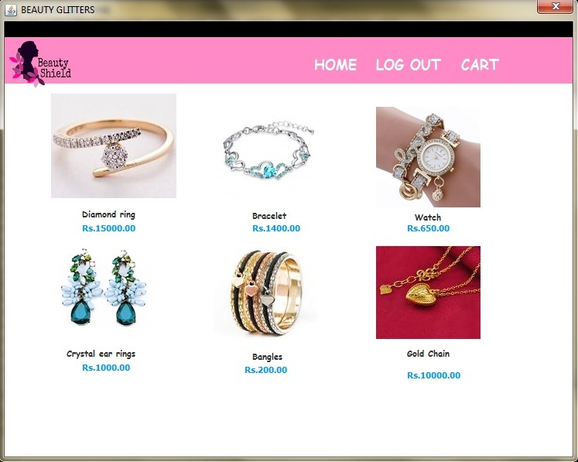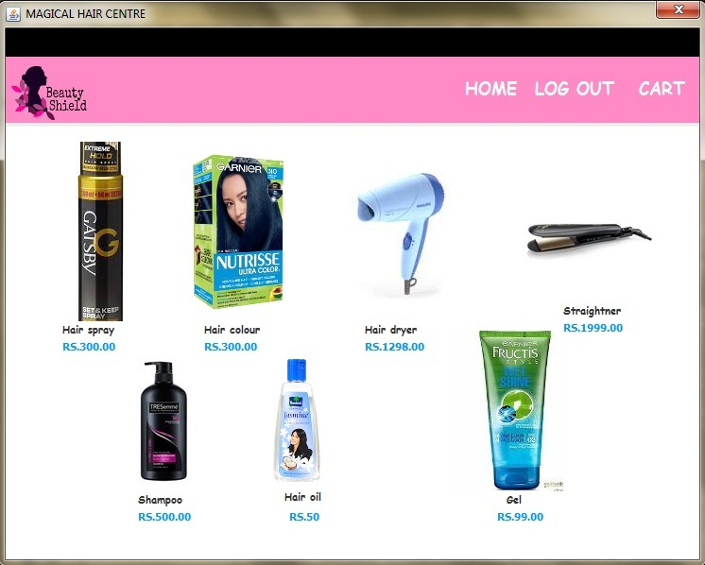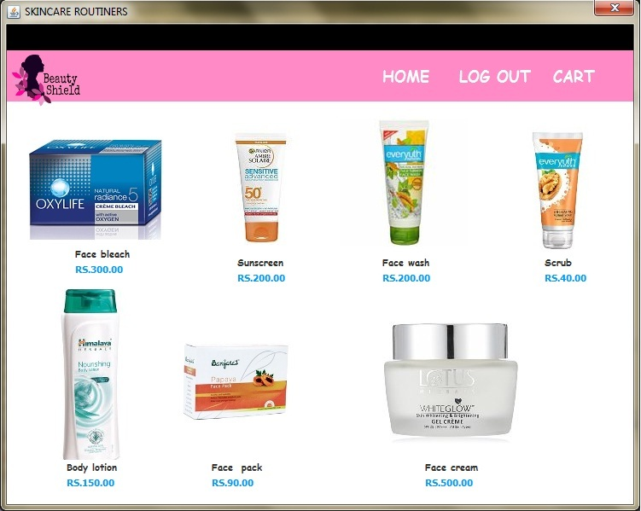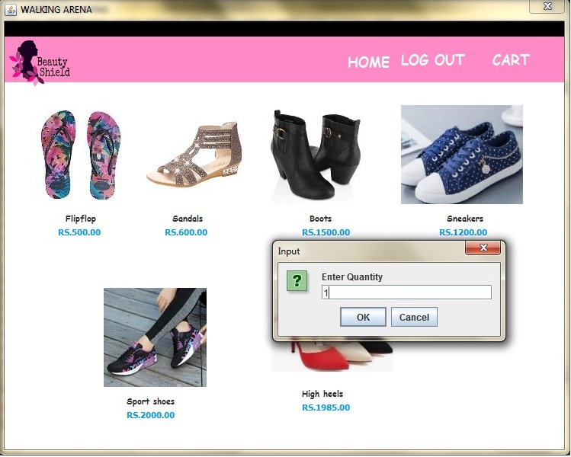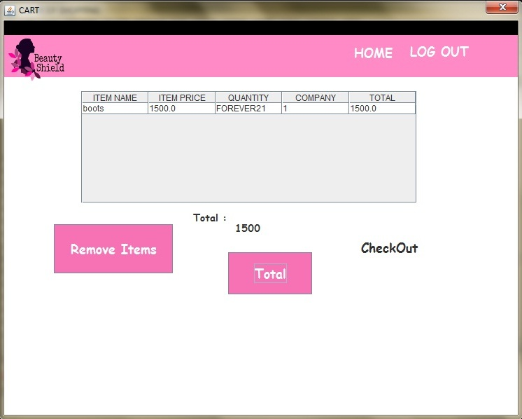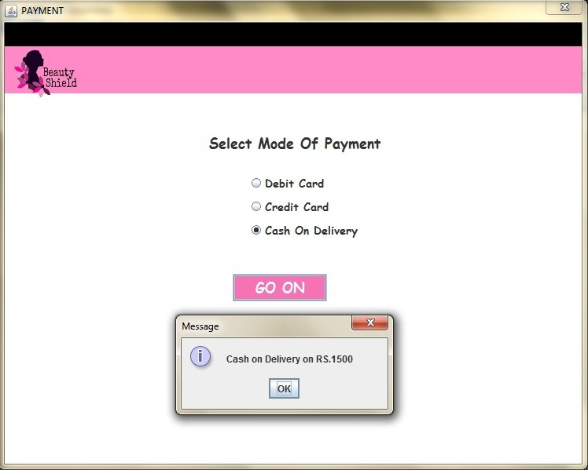

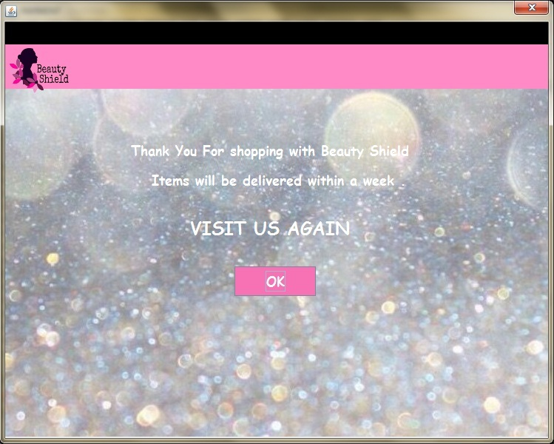

**CONCLUSION**

WHILE DEVELOPING THE PROJECT WE HAVE GONE INTO THE DETAILS OF HOW AN ONLINE SHOPPING WEBSITE SHOULD BE. HENCE, WE ASSUME THAT ALL THE INFORMATION WE HAVE PROVIDED IS ACCURATE. IT HAS BEEN AN EXPOSURE INTO SOFTWARE DEVELOPMENT USING A FRONTEND DEVELOPER TOOL AND BACKEND DATABASE. IT IS AN USER FRIENDLY PROGRAM WITH A CLEAR CUT INTERFACE ENSURING SMOOTH INTERACTION AND GENERATES FEEDBACK TO THE USER AS AND WHEN REQUIRED.

**BIBLIOGRAPHY**

* INFORMATICS PRACTICES CLASS XII -SUMITA ARORA
* [www.google.com](http://www.google.com)
* GOOGLE IMAGES